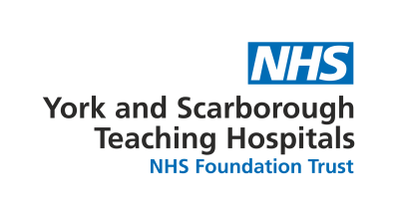
New Offer/ Discount Application
Thank you for considering becoming one of our fabulous partners!
Please complete the below form in full and email to staffbenefits@york.nhs.uk once completed
About you:
Name of company
Tell us a little bit about your company
Contact name and email
(in case we need to get in touch)

NHS discount:
What discount is available for NHS Staff?
Does this apply to all your services/ products or a select few (please state)
How do staff get this offer? (Show ID Badge/ discount code)
How long is the offer valid for? (Does it have an expiry or is it permanent)
Is this offer available to any NHS staff or only staff working for York and Scarborough Teaching Hospitals and its Facilities management team?

Advertising/ Marketing
Are you happy for us to advertise your offer on the following platforms (Please delete as appropriate) | Facebook: Yes / No  Instagram: Yes / No  Monthly Newsletter: Yes / No  Website (only available for permeant discounts/ offers): Yes / No
What are your online platforms (state N/A if not applicable): | Facebook:  Instagram:  Website:
Do you have any images/ logos we can use to advertise your offer? | Yes / No  If Yes please attach to your email (preferably in jpeg format)

We look forward to working with you!

