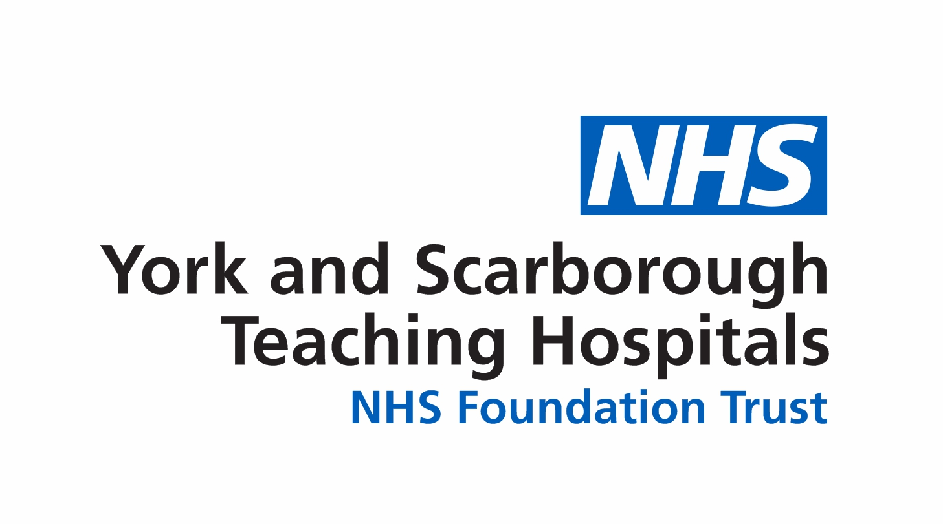

DC/mm | Directorate of Laboratory Medicine  York Hospital, Wigginton Road, York,YO31 8HE  Telephone: (01904) 631313
6th September 2022
Practice Manager | Dr Deepak Chandrajay  Consultant Chemical Pathology

Dear Colleagues

Discontinuation of urine pregnancy test

We are discontinuing the analysis of urine pregnancy tests in our laboratories at York and Scarborough hospitals from 1st October 2022.

Point of care urine HCG tests are already available at GP surgeries. Alternatively, patients should be advised to use commercially available home pregnancy kits.

If you have any queries, please contact the laboratory duty biochemist on 01904 726366.

Yours sincerely

Deepak Chandrajay

Dr Deepak Chandrajay
Consultant Chemical Pathology

