Item 11
Item 11
Item 11
Item 11.4
Item 11
Item 11
Item 11
Report to: | Board of Directors
Date of Meeting: | 31 January 2024
Subject: | Bi-annual Midwifery, Maternity and Neonatal Staffing Report  July-December 2023
Director Sponsor: | Dawn Parkes, Exectuive Chief Nurse
Authors: | Bev Waterhouse, Deputy Head of Midwifery  Georgina Rowe, Deputy Programme Manager  Ben Adekanmi, Clinical Director O&G  Molly Gasgoyne, Senior Ops Manager O&G  Sunny Sandhu, Consultant  Sal Katib, Head of Childrens Nursing  David Yates, Consultant in Anaesthatist

Status of the Report (please click on the appropriate box)
Approve Discuss Assurance Information A Regulatory Requirement

Trust Priorities  Our People  Quality and Safety  Elective Recovery  Acute Flow | Board Assurance Framework  Quality Standards  Workforce  Safety Standards  Financial  Performance Targets  DIS Service Standards  Integrated Care System

- Background

It is a requirement that as NHS providers we continue to have the right people with the right skills in the right place at the right time to achieve safer nursing and midwifery staffing in line with the National Quality Board (NQB) requirements.

Organisational requirements for safe midwifery staffing for maternity settings (NICE

2017) states that midwifery staffing establishments develop procedures to ensure that a systematic process is used to set the midwifery staffing establishment to maintain continuity of maternity services and to always provide safe care to women and babies in all settings.

Previously midwifery staffing data has been included in the nurse staffing paper, however, to provide evidence for NHS Resolutions Maternity CNST Incentive Scheme, a separate paper is now provided which also includes staffing data on other key groups, obstetricians, and anaesthetics.

- Executive Summary

This report gives a summary of all measures in place to ensure safe midwifery staffing; including workforce planning, planned versus actual midwifery staffing levels, the midwife to birth ratio, specialist hours, compliance with supernumerary labour ward coordinator (LWC), one to one care in labour and red flag incidents. It also gives a summary of key workforce measures for obstetricians and anaesthetics to provide evidence for the maternity incentive scheme year 5. The Trust will be unable to declare compliance against MIS Y5, Safety Action 5 due to the lack of supernumerary LWC status during this period. An action plan will be developed however it is recognised an increase in staff is necessary as per the Midwifery Workforce Business Case.

- Birthrate Plus Workforce Planning

A formal Birth Rate Plus assessment was completed in June 2021, which reviewed the acuity of women who used maternity services, at what was then, York and Scarborough Teaching Hospitals Foundation Trust.

NICE (2017) recommend that an assessment is carried out every three years. Although the service is still within the time to enable an updated position of the current workforce with the support of the Maternity Improvement Advisor and Birth Rate plus, we have undertaken a refresh of the 2021 data. Whilst this has allowed us to reflect on our current position, it is recognised that certain issues such as increase in acuity, geographical uplift and changes to the role of the LWC may demonstrate the need for further investment when BR+ assessment is formally repeated. The refresh recommended a birth to midwife ratio of 23.3 for York and 24.1 Scarborough. However, it is recognised nationally that due to the fluctuation in complexity of the women and acuity of services, the refresh does not provide us with enough assurance that the assessment will not be forthcoming with additional recommendations. Our ambition is to repeat a full assessment with Birth Rate + in Q3 2023.

The refresh highlighted a deficit of 2.47 WTE between Bands 3-7; there is recognition the staffing establishment deficit can be address through skill mixing. To achieve the 90/10 York recommendation, the Trust is partaking in the LMNS Level 4 HCA to MSW Training Programme designed to upskill Band 2 Health Care Assistants to Band 3 Midwifery Support Workers. The programme commences in September 23 with 24 HCA’s enrolled across 3 cohorts.

Additionally, a full Workforce Review is planned in conjunction with our Maternity Improvement Advisors and newly appointed Director of Midwifery.

- Planned Versus Actual Midwifery Staffing Levels

The following table outlines bank and agency filled hours within maternity services by month, along with information about unfilled hours with crude calculation of the WTE of both the filled and unfilled hours. NB. These figures do not include specialists and managers, however do include the Labour Ward Coordinator. Moving forward, the Labour Ward Coordinator will be considered as a specialist role inline with BirthRate+ recommendations and therefore will not be included.

Site 1: York

Q2

York | Agency/ Bank filled  hours | Crude measurement  of  WTE filled hours | Unfilled hours | Crude measurement  of  WTE unfilled hours
July 2023 | 2,890 | 17.8 | 4,030 | 24.8
Aug 2023 | 2,570 | 15.8 | 3,532 | 21.7
Sept 2023 | 2,782 | 17.1 | 2,296 | 14.1

Q3

York | Agency/ Bank filled  hours | Crude measurement  of  WTE filled hours | Unfilled hours | Crude measurement  of  WTE unfilled hours
Oct 2023 | 2,629 | 16.1 | 2,570.8 | 15.8
Nov 2023 | 3,093 | 19 | 1,798 | 11.1
Dec 2023 | 1,980 | 12.2 | 2,530 | 15.6

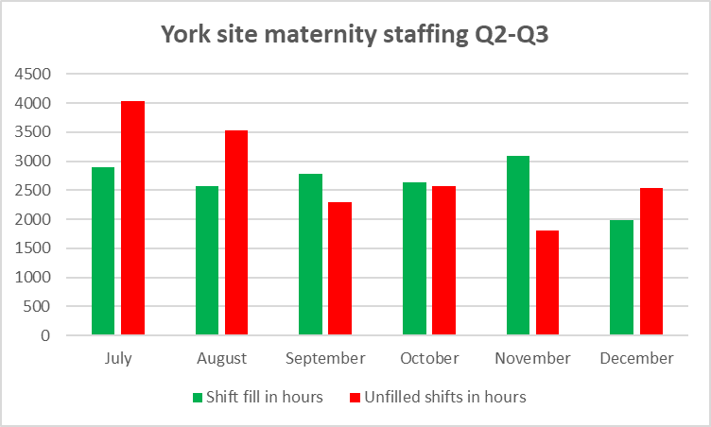

York have seen an improvement in the hours lost to unfilled shifts since July. In part this is attributed to increased usage of agency following an interim staffing review by our DoM. York have also seen a steady improvement in sickness rates, with the most common reason for sickness remaining anxiety, stress and depression.
Site 2: Scarborough

Q2

SGH | Agency/ Bank filled  hours | Crude measurement  of  WTE filled hours | Unfilled hours | Crude measurement  of  WTE unfilled hours
July 2023 | 1,339 | 8.2 | 3,430 | 21.1
Aug 2023 | 1,359 | 8.4 | 3,878 | 24
Sept 2023 | 1,135 | 7.0 | 3,876 | 23.9

Q3

SGH | Agency/ Bank filled  hours | Crude measurement  of  WTE filled hours | Unfilled hours | Crude measurement  of  WTE unfilled hours
Oct 2023 | 1,051 | 6.5 | 4,597 | 28.3
Nov 2023 | 1,410 | 8.7 | 4.343 | 26.7
Dec 2023 | 1,914 | 11.8 | 4,049 | 24.9

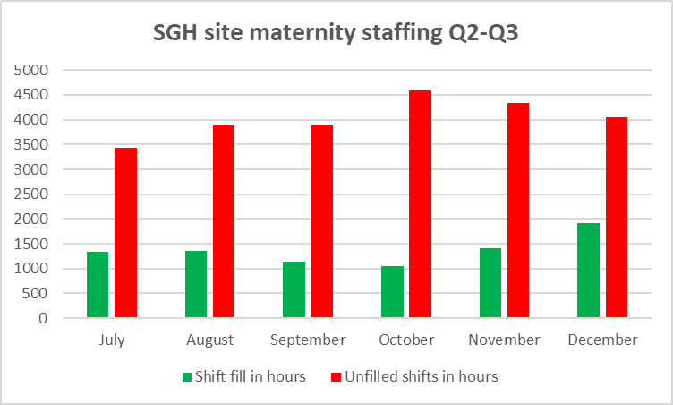

Scarborough’s fill rates remain static, however did improve slightly in December. Like York, sickness rates have steadily improved since July. Scarborough shifts have traditionally been more challenging to cover due to the location, however this did improve in December with block booked agency staff.
As demonstrated within the tables, there continues to be a significant number of unfilled shifts. We also acknowledge the number of vacant shifts covered, often by substantive staff, which places our staff at risk of the known effects of burnout.
The Ward Managers and Matrons continue to receive support with roster management and key performance indicators: however, the vacancies have been so significant despite regular oversight there is limited opportunity to improve the position. Work has now completed to split rosters according to teams, to allow for a more detailed understanding of shift fill and roster management. This support is being provided in a variety of ways to include from the roster management team, the Workforce Lead, and the Interim Director of Midwifery.
The escalation policy review continues, alongside our LMNS colleagues. There are no current plans to make changes to the out of hours maternity on call.
When staffing is less than optimum, a range of measures are taken in line with the escalation policy such as:
- Request midwifery staff undertaking specialist roles to work clinically.
- Elective workload prioritised to maximise available staffing.
- Managers at Band 7 level and above work clinically.
- Relocate staffing to ensure one to one care in labour and dedicated supernumerary labour ward co-ordinator roles is maintained.
- Activate the on-call midwives from inpatients / community to support labour ward.
All the above actions are designed to maximise staffing into critical functions to maintain safe care for the women and their babies. Historically, rosters have been created to have higher fill rates during the night shifts and weekends when there is less support available from specialist midwives and managers. Roster reviews have been more robust and managers trained in accordance with best practice; this training and focused work on rosters was completed in October 2023. A range of development modules including roster management will be offered on our newly designed B7 Fundamentals of Management course. Actions taken to support safe staffing are captured in the live birth rate plus acuity tool. Training sessions were delivered by BR+ during September to increase LWC understanding of the tool and compliance with completion. The ward-based acuity tool is not anticipated to be launched until early 2024.
At York, inpatient midwives have participated in an escalation on-call for several years. A recent consultation has concluded at Scarborough where the plan to undertake escalation on call which would enhance the availability for community midwives for homebirths. Progress has been paused as a full Workforce Review and BirthRate + Assessment is first required. This approach has not commenced as the output from both the review and assessment is required to enable the Director of Midwifery to support.
Band 7 managers and specialist midwives currently undertake a manger of the day role at each site, which supports escalation, staff breaks and patient flow. This role is highly valued, however removes mangers and specialists from their substantive roles. There is also evidence of significant variation in the quality on a day-to-day basis due to the variety of staff undertaking, without having formal training and role description. This role will be reviewed against recommendations for a dedicated flow midwife role as part of the Workforce Review.
There is recognition a Maternity Staffing SOP, which will include an escalation policy, is required to support less than optimum staffing levels. The Maternity Staffing SOP will be produced following a full Workforce Review which is expected to commence in September 2023 following the successful appointment of a substantive Director of Midwifery.

- Birth to Midwife Ratio

The birth to midwife ratio is calculated monthly using Birth Rate Plus methodology and the actual monthly delivery rate. This has now been added to the maternity dashboard so that it can be monitored alongside clinical data. The table outlines the real time monthly birth to midwife ratio.

* This metric is calculated manually. It is noted that this figure includes whole time equivalent midwives employed by the Trust, but does not account for sickness, maternity leave, supernumery status (international midwives) managers and specialist midwives. This calculation only counts the numbers of births and does not reflect the acuity of the women delivered.

Monthly births | July 23 | August 23 | Sept 23 | Oct 23 | Nov 23 | Dec 23
York | 220 | 248 | 213 | 228 | 244 | 222
Scarborough | 121 | 103 | 99 | 100 | 109 | 100

Monthly WTE | July 23 | August 23 | Sept 23 | Oct 23 | Nov 23 | Dec 23
York | 96.53 | 95.35 | 95.35 | 94.55 | * | *
Scarborough | 47.01 | 46.81 | * | 39.71 | * | *

Monthly Midwife  to Birth ratio | July 23 | August 23 | Sept 23 | Oct 23 | Nov 23 | Dec 23
York | 1:27 | 1:31 | 1:27 | 1:29 | * | *
Scarborough | 1:31 | 1:26 | * | 1:30 | * | *

Across the Trust this equates to:

 | July 23 | Aug 23 | Sept 23 | Oct 23 | Nov 23 | Dec 23
Ratio | 1:29 | 1:30 | * | 1:29 | * | *
Births | 341 | 351 | 313 | 328 | 353 | 322

* Data not yet available
Midwife: Birth Ratio calculated as number of births / WTE midwives. This is not adjusted for staff absence such as sickness, maternity leave. The table below illustrates the impact of including unfilled shifts, plus the addition of shifts filled with temporary staff. This reflects a more realistic position.
 | July 23 | Aug 23 | Sept 23 | Oct 23 | Nov 23 | Dec 23
Ratio when unfilled shifts deducted and temp staffing added | 1:37 | 1:40 | * | 1:41 | * | *
Births | 341 | 351 | 313 | 328 | 353 | 322

The impact of unfilled shifts (including vacancy, inadequate headroom, sickness and maternity leave) is significant, reducing our midwife to birth ratio to less than 1:37. There is currently no national recommendation for birth to midwife ratio due to a rise in the acuity based within maternity services.

- Specialist Midwives

Birth Rate Plus recommends that 8-11% of the total establishment are not included in the clinical numbers, with a further recommendation of this being 11% for multi-sited Trusts. This includes management positions and specialist midwives. The current percentage for York and Scarborough July-December 2023 is calculated to be 6.8%.

- Birth Rate Plus Live Acuity Tool

The Birth Rate Plus Live Acuity Tool was introduced in the intrapartum areas on both sites in April 2021 and on the other inpatient areas on June 2021. It is a tool for midwives to assess their ‘real time’ workload arising from the number of women needing care, and their condition on admission and during the processes of labour, delivery and postnatally. It is a measure of ‘acuity’, and the system is based upon an adaption of the same clinical indicators used in the well-established workforce planning system Birth Rate Plus.

The Birth Rate Plus classification system is a predictive/prospective tool rather than the retrospective assessment of process and outcome of labour used previously. The tool is completed four hourly by the labour ward co-ordinator. An assessment is produced on the number of midwives needed in each area to meet the needs of the women based on the minimum standard of one to one care in labour for all women and increased ratios of midwife time for women in the higher need categories. This provides an assessment on admission of where a woman fits within the identified Birth Rate Plus categories and alerts midwives when events during labour move her into a higher category and increased need of midwife support.

This safe staffing tool kit supports most of the components in the NICE Guidance (and is endorsed by NICE) on safe midwifery staffing for maternity settings necessary for the determination of maternity staffing requirements for establishment settings. It provides evidence of what actions are taken at times of higher acuity and use of the escalation policy when required.

The following provides evidence of actions taken (both clinical and management) to mitigate any shortfalls in staffing or for periods of high acuity.

York Q2 01/07/23 – 30/09/23

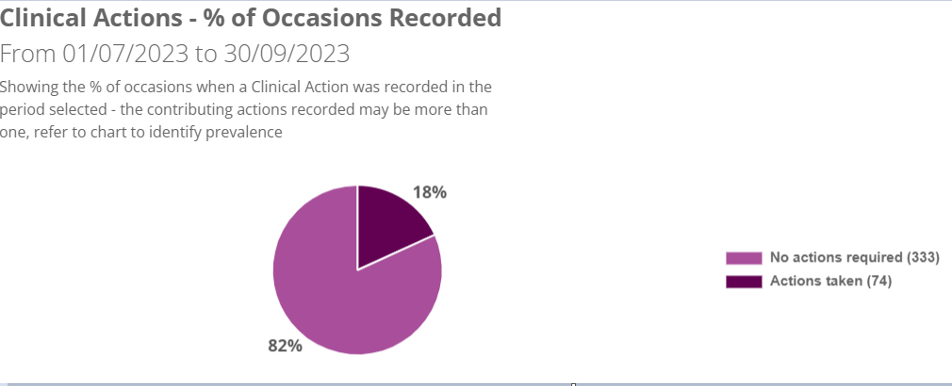

At the time of writing this paper, the BR+ tool was undergoing maintenance and Q3 was unavailable. The graph above shows that actions were required on 74 occasions (18%). These actions included delay in accepting transfers (n33), delay in induction activity (n26), decline in in-utero transfers (n16), delay in transfers to theatre (n2) and delays in elective c-section over 24hours (n2). Some women may have been affected by more than one clinical action.

Scarborough Q2 01/07/23 – 30/09/23

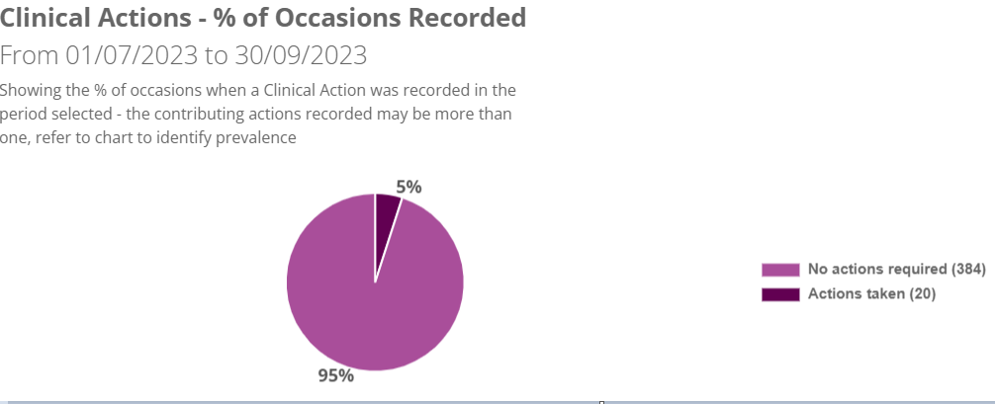

At the time of writing this paper, the BR+ tool was undergoing maintenance and Q3 was unavailable. The graph above shows that actions were required on 20 occasions (5%). These actions included delay in induction activity (n10), decline in in-utero transfers (n7), delay in transfers to theatre (n2), delay in planned procedure (n2). Some women may have been affected by more than one clinical action.

- Supernumerary Labour Ward Co-ordinator

Availability of a supernumerary labour ward co-ordinator is recommended as an essential component of safe maternity care. This is an experienced midwife available to provide advice, support, and guidance to clinical staff and able to manage activity and workload through the labour ward. The impact of inadequate staffing, and lack of triage at SGH will need to be addressed to improve this. An action plan will be drafted to address non-compliance as per MIS guidance.

The following table outlines the compliance by month:

Site 1: York

York | Number of episodes non-supernumerary status per month | Number of shifts per month | Compliance
July 2023 | 1 | 62 | 98.4%
August 2023 | 1 | 62 | 98.4%
September 2023 | 0 | 60 | 100%
October 2023 | 0 | 31 | 100%
November 2023 | 0 | 30 | 100%
December 2023 | 0 | 62 | 100%
*NB. Data to be interpreted cautiously as the BirthRate+ Acuity tool is validated at data entry of 85%. For Q2 – Q3, data entry range is 71-77% across site.

Site 2: Scarborough

Scarborough | Number of episodes non-supernumerary status per month | Number of shifts per month | Compliance
July 2023 | 4 | 62 | 93.5%
August 2023 | 13 | 62 | 79%
September 2023 | 8 | 60 | 86.7
October 2023 | 6 | 62 | 90.3
November 2023 | 10 | 60 | 83.4%
December 2023 | 4 | 62 | 93.5
*NB. Data to be interpreted cautiously as the BirthRate+ Acuity tool is validated at data entry of 85%. For Q2 – Q3, data entry range is 70-77% across site.

As demonstrated, SGH report non-compliance more frequently than York. In part this is due to not having a dedicated maternity triage which means the LWC regularly reviewed these attendees on labour ward. A full workforce review, led by the newly appointed Director of Midwifery, is underway. There is recognition staffing levels are inadequate with ongoing discussions to agree appropriate next steps. BirthRate+ delivered acuity tool refresher training sessions during the month of September 23. Despite additional training, LWC data input remains under the 85% entry requirement to ensure data validity. The Trust will be unable to declare compliance against MIS Y5, Safety Action 5 against supernumerary LWC status during this period and an action plan will be developed in like with the Midwifery Workforce Business Case.

- One to One in Established Labour

Women in established labour are required to have one to one care and support from an assigned midwife. One to one care will increase the likelihood of the woman having a ‘normal’ vaginal birth without interventions and will contribute to reducing both the length of labour and the number of operative deliveries. Care will not necessarily be given by the same midwife for the whole labour.

If there is an occasion where one to one care cannot be achieved, then this will prompt the labour ward co-ordinator to follow the course of actions within the acuity tool. These may be clinical, or management actions taken.

The following table outlines compliance by Month.

Site 1: York

York Q2 | July 2023 | August 2023 | September 2023
One to one Care in labour | 100% | 100% | 100%
York Q3 | Oct 2023 | Nov 2023 | Dec 2023
One to one Care in labour | 100% | 100% | 100%

Site 2: Scarborough

SGH Q2 | July 2023 | August 2023 | September 2023
One to one Care in labour | 100% | 100% | 100%

SGH Q3 | Oct 2023 | Nov 2023 | Dec 2023
One to one Care in labour | 100% | 100% | 100%

Both sites achieved 100% compliance across July-December 2023.

- Red Flag Incidents

A midwifery red flag event is a warning sign that something may be wrong with midwifery staffing (NICE 2015). If a midwifery red flag event occurs, the midwife in charge of the service is notified. The midwife in charge will then determine whether midwifery staffing is the cause and the action that is needed. Red flags are collected through the live Birth Rate Plus acuity tool.

The following tables demonstrate red flag events on each site:

Site 1: York Q

 | Red Flag Incidents York Q2 | July  23 | August  23 | September  23
1 | Delayed or cancelled time critical activity | 8 | 6 | 7
2 | Missed or delayed care (for example, delay of 60 minutes or more in washing and suturing) | 2 | 0 | 0
3 | Missed medication during an admission to hospital or midwifery-led unit (for example, diabetes medication) | 0 | 0 | 0
4 | Delay in providing pain relief  Delay of more than 30 minutes | 0 | 0 | 0
5 | Delay between presentation and triage  Delay of 30 minutes or more | 0 | 0 | 0
6 | Full clinical examination not carried out when presenting in labour | 0 | 0 | 0
7 | Delay between admission for induction and beginning of process  Delay of 2 hours or more | 4 | 1 | 1
8 | Delayed recognition of and action on abnormal vital signs (for example, sepsis or urine output) | 0 | 0 | 0
9 | Any occasion when one midwife is not able to provide continuous one-to-one care and support to a woman during established labour | 0 | 0 | 0
10 | Coordinator not able to maintain supernumerary/supervisory status | 1 | 1 | 0
Subtotal: |  | 15 | 8 | 8
Total red flags for July-September 2023

 | Red Flag Incidents York Q3 | Oct  23 | Nov  23 | Dec  23
1 | Delayed or cancelled time critical activity | 4 | 7 | 5
2 | Missed or delayed care (for example, delay of 60 minutes or more in washing and suturing) | 1 | 0 | 0
3 | Missed medication during an admission to hospital or midwifery-led unit (for example, diabetes medication) | 0 | 0 | 0
4 | Delay in providing pain relief  Delay of more than 30 minutes | 0 | 0 | 0
5 | Delay between presentation and triage  Delay of 30 minutes or more | 0 | 0 | 0
6 | Full clinical examination not carried out when presenting in labour | 0 | 0 | 0
7 | Delay between admission for induction and beginning of process  Delay of 2 hours or more | 0 | 0 | 0
8 | Delayed recognition of and action on abnormal vital signs (for example, sepsis or urine output) | 0 | 0 | 0
9 | Any occasion when one midwife is not able to provide continuous one-to-one care and support to a woman during established labour | 0 | 0 | 0
10 | Coordinator not able to maintain supernumerary/supervisory status | 0 | 0 | 0
Subtotal: |  | 5 | 7 | 5
Total red flags for October-December 2023

Site 2: Scarborough

 | Red Flag Incidents Scarborough | July  23 | August  23 | September  23
1 | Delayed or cancelled time critical activity | 0 | 0 | 0
2 | Missed or delayed care (for example, delay of 60 minutes or more in washing and suturing) | 1 | 0 | 0
3 | Missed medication during an admission to hospital or midwifery-led unit (for example, diabetes medication) | 0 | 0 | 0
4 | Delay in providing pain relief  Delay of more than 30 minutes | 0 | 0 | 0
5 | Delay between presentation and triage  Delay of 30 minutes or more | 0 | 0 | 0
6 | Full clinical examination not carried out when presenting in labour | 0 | 0 | 0
7 | Delay between admission for induction and beginning of process  Delay of 2 hours or more | 5 | 1 | 0
8 | Delayed recognition of and action on abnormal vital signs (for example, sepsis or urine output) | 0 | 0 | 0
9 | Any occasion when one midwife is not able to provide continuous one-to-one care and support to a woman during established labour | 0 | 0 | 0
10 | Coordinator not able to maintain supernumerary/supervisory status | 4 | 13 | 8
Subtotal: |  | 10 | 14 | 8
Total red flags for July-September 2023

 | Red Flag Incidents Scarborough Q3 | Oct  23 | Nov  23 | Dec  23
1 | Delayed or cancelled time critical activity | 0 | 2 | 0
2 | Missed or delayed care (for example, delay of 60 minutes or more in washing and suturing) | 0 | 0 | 0
3 | Missed medication during an admission to hospital or midwifery-led unit (for example, diabetes medication) | 0 | 0 | 0
4 | Delay in providing pain relief  Delay of more than 30 minutes | 0 | 0 | 0
5 | Delay between presentation and triage  Delay of 30 minutes or more | 0 | 0 | 0
6 | Full clinical examination not carried out when presenting in labour | 0 | 0 | 0
7 | Delay between admission for induction and beginning of process  Delay of 2 hours or more | 0 | 0 | 0
8 | Delayed recognition of and action on abnormal vital signs (for example, sepsis or urine output) | 0 | 0 | 0
9 | Any occasion when one midwife is not able to provide continuous one-to-one care and support to a woman during established labour | 0 | 0 | 0
10 | Coordinator not able to maintain supernumerary/supervisory status | 6 | 10 | 4
Subtotal: |  | 6 | 12 | 4
Total red flags for October-December 2023

During Q2 2023 the red flag data reflected delays in both induction of labour admissions and transfer to labour ward. Data entry for time critical delays included delays in patient flow which was not necessarily time critical and therefore should not have been included. Ongoing work is taking place to support accurate data entry. Local red flag data is collected and reviewed on a monthly basis.
- Obstetric staffing

The rotas and skill mix on both sites for obstetric staffing on the labour ward are in line with RCOG guidelines for entrustability and include the use of locum staff where necessary to ensure rotas do not have gaps.
The summary of obstetric staffing across both sites is summarised below:
York Q2 |  |  |  | Scarborough Q2
 | No. of Drs | WTE |  |  | No. of Drs | WTE
Tier 1 (ST1-3) | 10* * | 8.9 |  | Tier 1 (ST1-3) | 4 ^ | 4
Tier 2 (ST4-ST8) | 7 ** | 5.4 |  | Tier 2 (ST4-ST8) | 8 ^^ | 6.8
Tier 3 (Consultant) | 18 *** | 17.5 |  | Tier 3 (Consultant) | 10 **** | 10
* includes 3 locum drs |  |  |  | ^ includes 3 locum drs
** includes 1 Speciality dr |  |  |  | ^^ includes 2 Specialty drs and 3 locum drs
*** includes 2 Consultants working cross-site |  |  |  | **** includes 2 Consultants working cross-site and 2 long-term locum

York Q3 |  |  |  | Scarborough Q3
 | No. of Drs | WTE |  |  | No. of Drs | WTE
Tier 1 (ST1-3) | 10* * | 8.9 |  | Tier 1 (ST1-3) | 4 ^ | 4
Tier 2 (ST4-ST8) | 7 ** | 5.4 |  | Tier 2 (ST4-ST8) | 7 ^^ | 6.8
Tier 3 (Consultant) | 18 *** | 17.5 |  | Tier 3 (Consultant) | 10 **** | 10
* includes 3 locum drs |  |  |  | ^ includes 3 locum drs
** includes 1 Speciality dr |  |  |  | ^^ includes 2 Specialty drs and 3 locum drs
*** includes 2 Consultants working cross-site |  |  |  | **** includes 2 Consultants working cross-site and 2 long-term locum

The non-resident Consultants will come on to site if there are gaps which cannot be mitigated with locum staff. Their time is compensated should they attend on-site in line local guidance. Shifts are then backfilled.
The Trust ensures the criteria for employing short term locums (2weeks or less) in obstetrics and gynae on tier 2 and 3 (middle grade) who work on the tier 2 and 3 rota by the completion of the standard and enhanced compliance checks undertaken as part of the on-boarding process. The on-boarding of locum medical staff is overseen by the Trust medical staffing team and is supported by a defined checklist which ensures all qualifications and competency is reviewed. A draft SOP is in development.
Medical Bank and Agency team are implementing the monitoring/effectiveness tool from Jan 2024 onwards to support monitoring and compliance to ensure the Trust adheres with the standards relating to long term locums.
Providing cover via patchwork are assessed while working on the unit in their current or previous rotations as part of the training programme with satisfactory Annual Review of Competency Progression (ARCP)
From July to December 2023 there was only one long-term locum consultant used by the obstetric service who are fully integrated into the obstetric team with the same training, compliance and oversight as with employed medical colleagues. There have been 2 lower tier and one 1 long term lower tier drs used by the obstetric service to cover vacancy gaps in the rota.
Current short-term locum Tier 2 middle grade shifts are picked up through Patchwork or contacted direct by our current or recent trainees/middle grade drs on our regional trainee programme via the rota teams.
Any long-term locums employed on the middle grade rota are assigned Consultant Clinical and Educational Supervisors and are initially after a period of supernumerary induction role, supervised directly on site by Resident Consultants in the day on both sites and out of hours on York site, before progression to indirect supervision where deemed appropriate after assessments by the Educational Supervisor and the Consultant team. There are currently no long-term middle grade obstetric locums employed on either site.
The Scarborough rota has two unfilled permanent Consultant vacancies and one long-term absence in the rota; the individual is on a phased return to work and their job plan will be reviewed in accordance with Trust policy. There is recognition there may be gaps in the rota which will require additional investment following the completion of the full job plan review. The long-term absence vacancy is being covered by a locum, one substantive consultant vacancy is being backfilled with a long-term locum and the remaining substantive consultant vacancy is still unfilled. The job description is under review to align with the integration of cross-site working recruitment.

There is daily monitoring of Consultant compliance with Consultant attendance at ward round in person. Attendance is monitored using the daily sign-in register which is completed 3x per day weekdays and 2x per day on weekends. The register was monitored by the Labour Ward Managers with escalation made to where needed from the Clinical Director and with oversight from the Maternity Senior Leadership Team weekly to support any action plans as required to prevent further non-attendance. The current audit plan is to do snapshot audits of patient records to confirm evidence of daily consultant ward rounds and reviews. A full review of the Maternity and Neonatal Governance Quality and Safety Framework is underway aligned with the restructuring of corporate governance functions.

The Trust is currently non-complaint with the requirement to monitor Consultant attendance at clinical situations listed in the RCOG workforce document. This process is currently under review by the Clinical Director.

The Trust is aware of and aims to implement and follow the RCOG guidance on compensatory rest where consultants and senior Speciality and Specialist (SAS) doctors are working as non-resident on-call out of hours and do not have sufficient rest to undertake their normal working duties the following day. A draft SOP has been produced and is currently under review. The operational administration team are available to attend daily handovers, when required, to support any changes to the rota to ensure compliance is achieved. A review of the obstetric workforce is ongoing and supported by the Maternity Safety Support Programme (MSSP) which will inform any further rota management, recruitment and succession planning as well as finalising job planning for the Consultant team. A review of non-resident consultant rota pattens against planned work activity to ensure full compliance. This review will incorporate insight from the current audit (diary log of activity) for non-resident on-call which will be used to check if impact on activity the following day will be expected.
- Anaesthetic staffing

The trust can confirm that there is a duty anaesthetist immediately available for the obstetric unit 24 hours a day and the unit has clear lines of communication to the supervising anaesthetic consultant at all times. Where the duty anaesthetist has other responsibilities, they are able to delegate care of their non-obstetric patients in order to be able to attend immediately to obstetric patients in line with ACSA standard 1.7.2.1. The anaesthetic rotas for the period July to December 2023 have been reviewed and audited and this demonstrates 100% compliance.

- Neonatal medical staffing

To meet Safety Action 4 of the Maternity Incentive Scheme (MIS), the neonatal unit needs to demonstrate that it meets the British Association of Perinatal Medicine (BAPM) national standards for junior medical staffing. If the requirements had not been met in both year 3 and year 4 of MIS, Trust Board should evidence progress against the action plan developed in year 3 of MIS as well as include new relevant actions to address deficiencies.

The BAPM guidance for junior medical staffing of neonatal units recommends that, as York is a Local Neonatal Unit, it requires immediately available at least one resident tier 1 practitioner dedicated to providing emergency care for the neonatal service 24/7 and also an immediately available resident tier 2 practitioner dedicated solely to the neonatal service during the periods which are usually the busiest in a co-located Pediatric Unit e.g. between 09.00 - 22.00, seven days a week. Local data review has demonstrated that for our service, the busiest period is usually up to midnight.​ Funding and midwifery time for this still need to be agreed.

The number of junior doctors on both the tier 1 and tier 2 child health rotas are insufficient to meet this requirement and to allow a separate tier 1 rota for the neonatal service out of hours (being addressed).

Currently there is a separate tier 1 doctor for the neonatal unit and postnatal ward during 9-5 hours every day. Two tier 1 doctors are on shift in the evening from 5-9pm (weekdays only) then only one overnight who covers both paediatrics and neonates. The neonatal unit tier 1 doctor is usually the first doctor to get reallocated if there is a rota gap during the daytime. At weekends, the tier 1 doctor covers both paediatrics and neonates. An additional tier 1 doctor has been employed since September 2023. This will enable the current rota to be adjusted and allow an extra tier 1 doctor to be on shift overnight. Additionally, there have been discussions about providing midwifery newborn examination (NIPE) clinics which will ‘free-up’ additional tier 1 doctor time during the day to support the neonatal service. Funding and midwifery time for this still need to be agreed.

The neonatal operational delivery network (ODN) are aware of the medical workforce gaps and are trying to identify a regional solution to this problem. Following a gap analysis undertaken by the ODN and an application process, the trust have been awarded £25,500 (part-year – released and in trust as per October 2023 payments) and £62,400 (full-year recurrent funding from March 2024) to support an additional tier 2 paediatric post at York, see Appendix 1. Neonatal Workforce Action Plan 2023 York. Consequently, a business case was written and will go to Trust Board in January 2024 for consideration. The Business case outlines how these funds will be used and recommends 2x additional tier 2 post to enable full rota compliant with the BAPM standards. Additionally, the neonatal ODN are using Ockenden underspend to support international recruitment via an agency. While the business case is pending approval, staffing compliance remains an ongoing issue and is logged on the trust risk register which is reviewed regularly.

- Neonatal nursing staffing

To meet safety action 4 of the maternity incentive scheme the neonatal unit needs to demonstrate that it meets the service specification for neonatal nursing standards.

The Trust is required to formally record to the Trust Board minutes compliance to BAPM Nurse staffing standards annually using the Neonatal Nursing Workforce Calculator (2020). For units that do not meet the standard, the Trust Board should agree an action plan and evidence progress against any action plan previously developed to address deficiencies. A copy of the action plan, outlining progress against each of the actions, should be submitted to the LMNS and Neonatal Operational Delivery Network (ODN)

BAPM nurse staffing tool is completed every 3 months for Neonates cross site. A new cross-site Neonatal Medical Lead and Nursing Lead are exploring alternative models with neighbouring Trusts.

The Trust falls marginally short of the 70% Qualified in Speciality (QIS) staff for York and Scarborough due to recent leavers. This will be addressed with additional training for one staff member on each site which will the meet required standard.

There is a surplus of non-registered staff in York however 2 members of staff are currently undertaking the Nursing Associate training and 2 more will commence next financial year.

Band 7 roles is established for Nurse Education (including journal club) and time is allocated for breast feeding, BLISS and UNICEF work.

York staffing review summary Q2 2023

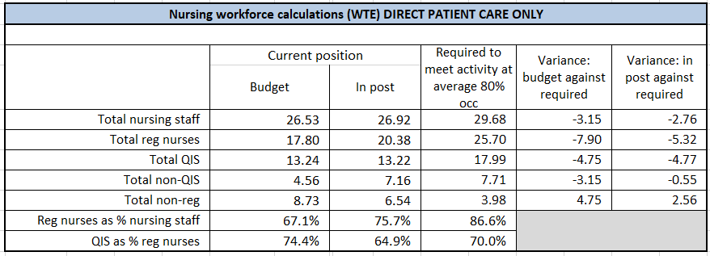

York staffing review summary Q3 2023

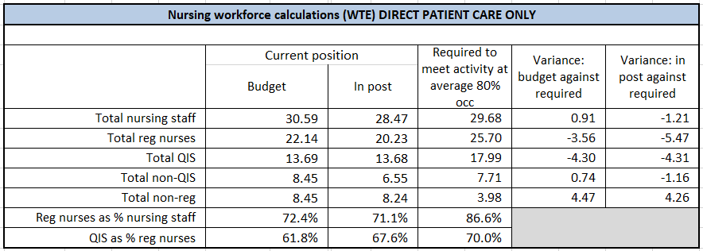

Scarborough staffing review Q2 2023

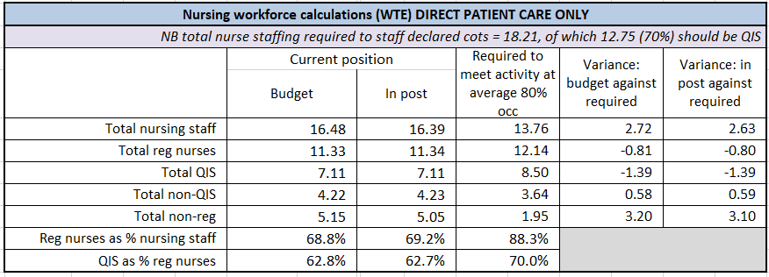

Scarborough staffing review Q3 2023

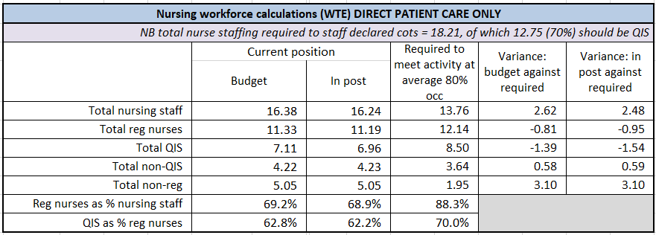

Scarborough SCBU is a small level one unit with a current staffing model of 2 Registered Nurses (1 QIS) and 1 non-registered nurse. The options appraisal will include looking at the need for a supernumerary nurse pragmatically.

Action | People responsible | Time Frame | Update
Develop Options Appraisal for supernumerary nurse in charge. | Interim ACN (HoN)  Matron for Neonates  Operational Manager | April 2024 | ATAIN Safety Champions are conversing and have plans to visit neighbouring Trusts to understand their TC models.  Cross-site MDT meeting to follow to scope a formal TC offering.
Create business case for above dependant on options appraisal | Business Manager  ACOO  HoN | Paused | Paused pending the above.

- Recommendations

The Board is asked to note the contents of the report and consider against the Midwifery Workforce business case and the Neonatal Medical Staffing business case. The Trust Board is asked to formally agree to the attached action plans.

Appendix 1. Neonatal Workforce Action Plan 2023 York
Reducing admission of full-term babies to Neonatal Unit

Report on Q4 2022/23, Q1 2023/24, Q2 2023/24 and Q3 2023/24

S. Kinsella and H. Harness
08/01/24

Background

This report outlines the findings of the ATAIN Review Panel during Q4 2022/23 – Q3 2023/24. The purpose of the ATAIN Review Panel is to review all qualifying admissions to the SCBU with a view reducing separation of mothers/birthing individuals and their babies by identifying good practice and areas for improvement as a multidisciplinary team.
The national average for unexpected admission for term (37+0 onwards) babies is 5%. The overall rate for YSTHFT was 4.1% Q4 and 2.9% Q1. Through Q2 3.8% and Q3 3.2% as a whole Trust it continued to be below 5%. It is important to note site differences, SGH admission rate is above the 5% nationally expected rate (see below) in all quarters.
The ATAIN Review Panel is a MDT who meets monthly. The panel includes a neonatal lead, neonatal matron, obstetric lead, obstetric matron, labour ward managers and maternity and neonatal clinical educators. Immediate actions are fed back monthly through the Clinical Governance platforms for both Neonatal and Obstetrics/Maternity.
Themes that occur more than twice per month (or three times in one quarter) are added to the overarching ATAIN Action Plan (see appendix 2). Please see Appendix 1 for an example monthly report which will include clearly defined immediate effects to ensure that all appropriate staff are updated.
The work aligns with national priorities including:

- The Secretary of State for Health’s ambition to reduce stillbirth, neonatal brain injury and neonatal death by 50% by 2030
- Recommendations in Better Births, taken forward in the NHS England-led Maternity Transformation Programme
- Reducing harm through learning from serious incidents and litigation claims
- Improving culture, team work and improvement capability within maternity units.

The review panel continues to use the bespoke local data collection tool to capture themes and trends. The tool asks the reviewer to identify the primary reason for admission and if any changes in the Antenatal/perinatal or postnatal management could have prevented admission. It also identified those babies where Transitional Care would have been a preferrable option to SCBU admission, thus reducing separation.

Objectives
The number of unexpected admissions to neonatal units is seen as a proxy indicator that preventable harm may have been caused at some point along the maternity or neonatal pathway. Additionally, admission to a neonatal unit can lead to unnecessary separation of mother and baby. There is overwhelming evidence that separating mother and baby at, or soon after, birth can affect the positive development of the mother-child attachment process and adversely affect maternal perinatal mental health. (NHS England » Reducing admission of full term babies to neonatal units). It is therefore and should be an area of focus for improvement.
Admissions to Neonatal Units.
Data
The Trust has robust data for the last 12 months which has been used to identify themes and actions.
Babies who have been admitted to the neonatal unit are split by site:
% | York Term admissions | Total term births  York | York Term admissions as a percentage of all term births at York | Scarborough Term admissions | Total term births SGH | SGH Term admissions as a percentage of all term births SGH
Q4 22/23 | 9 | 576 | 1.5% | 24 | 284 | 8.4%
Q1 23/24* | 10 | 620 | 1.6% | 14 | 246 | 5.6%
Q2 | 18 | 624 | 2.8% | 17 | 296 | 6.1%
Q3 | 16 | 647 | 2.4% | 14 | 278 | 5.03%
Total | 53 | 2467 | 2.1% | 69 | 1104 | 6.2%
*The April birth rate data is not robust due to the change over from Signal to BadgerNet data collection

Graph 1.
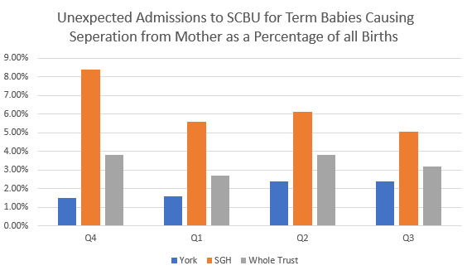
Graph 1. Unexpected admissions to the Special Care Baby Unit casing separation from mother as a percentage of all births from Q4 2022/23 - Q3 2023/24

YSTHFT achieved an admission rate below the national target of less than 5% term admission to the neonatal unit. As seen in the table above, Scarborough maternity have a higher then national average of term admission, this is likely to be related to the lack of transitional care facilities on site. There are currently plans in place to look at how this can be addressed to reduce the amount of term admissions to SCBU which will reduce the separation of mum and baby whilst still providing the care the baby’s need.

The ATAIN review panel examines each case and declares whether it was an avoidable admission or appropriate admission to SCBU as depicted in the charts below.

Graph 2. Graph 3.
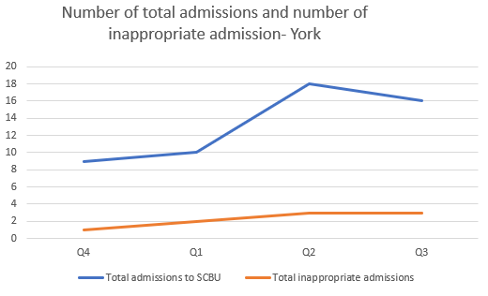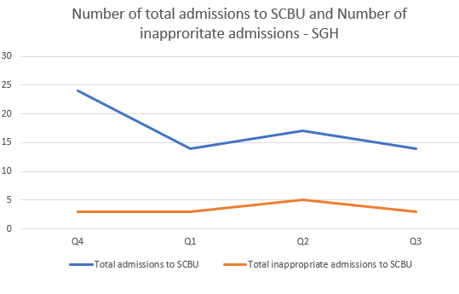
Graph 2 and 3. Number of total admissions and number of inappropriate admissions for York and Scarborough Q4 2022/23 - Q3 2023/24

Upon review, York had 9 avoidable admissions; 8 of which could have been cared for in Transitional Care. 1 baby did not require admission to either SCBU or TC and needed longer to transition and adapt to extra-uterine life. This baby could have remained with its parents and been re-reviewed at the bedside.

SGH had 13 avoidable admissions; 8 of which could have been cared for in Transitional Care if there had been facility available, the remaining 5 did require admission and needed longer to transition and adapt to extra-uterine life. These babies could have remained with their parents and been re-reviewed at the bedside.

Reason for Admission
The panel have further investigated the inappropriate admissions to find two main themes that occurred throughout the year. The following graph identifies all avoidable theme from both sites. This will form the basis of the action plan for the Q4 2023/24.

Graph 4.
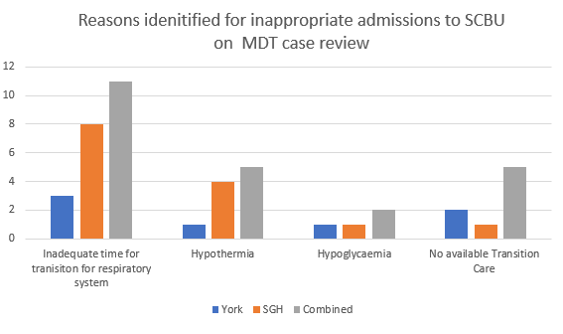
Graph 4. Reasons identified for inappropriate admission to Special Care Baby Unit on a multidisciplinary case review Q4 2022/23 - Q3 2023/24

The addition of a Clinical Governance Midwife at the ATAIN review panel has aided the completion and oversight of DATIX themes and actions. We are currently developing a Duty of Candour process which will be delivered to parents, with support and parental feedback gathered when an admission is deemed avoidable.

Transitional Care

Between Q4 2022/23 - Q3 2023/24, 14 babies could have been cared for in Transitional Care (TC) rather than admitted to SCBU; 5 in Scarborough and 9 in York. The ATAIN panel frequently found the use of TC would have kept mother/birthing individual and their baby together; however, York TC is frequently closed and there is no TC provision in SGH. The ATAIN Champions plan to visit a neighbouring Trust to deepen their understanding on transitional care models and explore the art of the possible. A cross-site MDT scoping session will follow and form the basis of the improvement action plan and regular task and finish groups to be established. While there is a Transitional Care SOP, it is recognised this will require update following output of task and finish groups and exploration exercise.
Conclusions and Recommendations
Scarborough and York have noticeable differences in term admissions rates. The main themes identified by the ATAIN Review Panel for avoidable are similar; namely infants requiring longer to transition and the lack of sustained Transition Care provisions on both sites. These will be the key lines of enquiry and exploration in the 2024 ATAIN Action Plan.
All admission notes were reviewed by the MDT ATAIN Review Panel and immediate finding actioned alongside identification of broader themes which will be added to the ATAIN Action Plan for the purpose of oversight by Maternity and Neonatal Governance Leads. Concerns and escalations from this Action plan are shared as part of local Trust governance processes.
The Trust Board is asked to formally agree to the action plans detailed in appendix 2.
Appendix 1 ATAIN Monthly Report Example
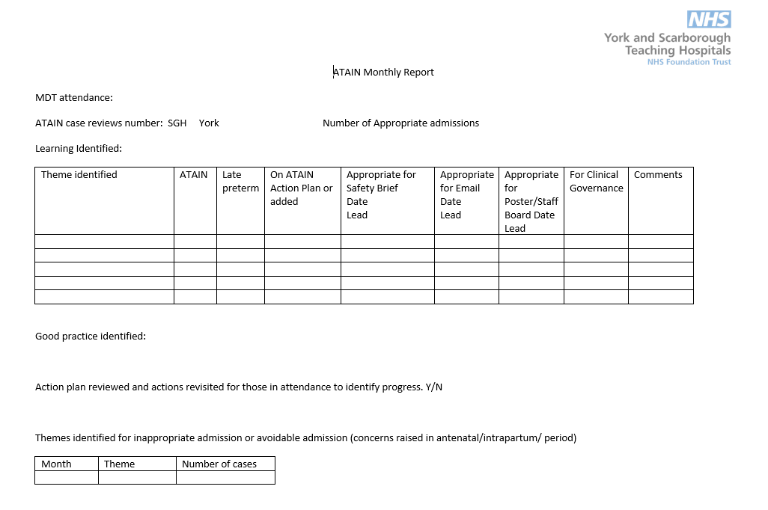
Appendix 2 ATAIN Action Plans
Scarborough ATAIN Action Plan Q2 2023

Scarborough ATAIN Action Plan Q3 2023

York ATAIN Action Plan Q2 2023

York ATAIN Action Plan Q3 2023

