Report to: | Board of Directors Public
Date of Meeting: | 26 June 2024
Subject: | Bi-annual Midwifery, Maternity and Neonatal Staffing Report  Oct – March 24
Director Sponsor: | Dawn Parkes, Chief Nurse
Authors: | Sascha Wells-Munro, Director of Midwifery  Bev Waterhouse, Deputy Head of Midwifery  Georgina Rowe, Deputy Programme Manager
Item 12.2
Item 12.2
Item 12.2
Item 12.1

Item 12

Status of the Report (please click on the appropriate box)
Approve Discuss Assurance Information A Regulatory Requirement

Trust Priorities  Our People  Quality and Safety  Elective Recovery  Acute Flow | Board Assurance Framework  Quality Standards  Workforce  Safety Standards  Financial  Performance Targets  DIS Service Standards  Integrated Care System

- Background

It is a requirement that as NHS providers we continue to have the right people with the right skills in the right place at the right time to achieve safer nursing and midwifery staffing in line with the National Quality Board (NQB) requirements.

Organisational requirements for safe midwifery staffing for maternity settings (NICE 2017) states that midwifery staffing establishments develop procedures to ensure that a systematic process is used to set the midwifery staffing establishment to maintain continuity of maternity services and to always provide safe care to women and babies in all settings.

Previously midwifery staffing data has been included in the nurse staffing paper, however, to provide evidence for NHS Resolutions Maternity CNST Incentive Scheme, a separate paper is now provided which also includes staffing data on other key groups, obstetricians, and anaesthetics.

- Executive Summary

This report gives a summary of all measures in place to ensure safe midwifery staffing; including workforce planning, planned versus actual midwifery staffing levels, the midwife to birth ratio, specialist hours, compliance with supernumerary labour ward coordinator (LWC), one to one care in labour and red flag incidents. It also gives a summary of key workforce measures for obstetricians and anaesthetics to provide evidence for the maternity incentive scheme year 5. An action plan has been developed however it is recognised an increase in staff is necessary as per the Midwifery Workforce Business Case.

- Birthrate Plus Workforce Planning

A full assessment by Birthrate Plus has been completed, with full report at the end of May 2024.
The final report will be shared through care group governance process and then reported to the July Quality committee and then Trust Board.

- Planned Versus Actual Midwifery Staffing Levels

The following table outlines bank and agency filled hours within maternity services by month, along with information about unfilled hours with crude calculation of the WTE of both the filled and unfilled hours.

Site 1: York

Q3/Q4 2023/24

York | Agency/ Bank filled  hours | Crude measurement  of  WTE filled hours | Unfilled hours | Crude measurement  of  WTE unfilled hours
Oct 2023 | 2,622 | 16.1 | 3,553 | 21.9
Nov 2023 | 3,182 | 19.5 | 2,508 | 15.5
Dec 2023 | 1,990 | 12.2 | 2,512 | 15.5
Jan 2024 | 3,045 | 18.7 | 1,912 | 11.8
Feb 2024 | 3,362 | 20.7 | 2 2,220 | 13.7
March 2024 | 3,823 | 23.5 | 2,055 | 12.6

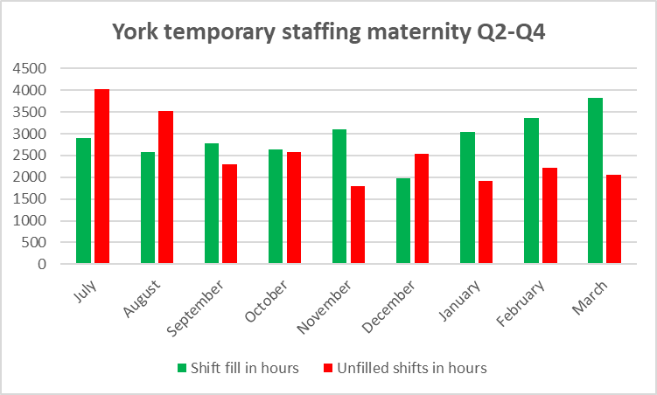

York have seen an improvement in the hours lost to unfilled shifts since July 2023. In part this is attributed to a robust process for the use of bank and agency to fill the gaps in the agreed e-roster staffing template. York have also seen a steady improvement in sickness rates. For this reporting period, sickness ranged from 3.59% (Community Midwifery) to 6.39% (G2), with the most common reason for sickness being cough, cold, ‘flu.

Site 2: Scarborough
Q3-Q4

SGH | Agency/ Bank filled  hours | Crude measurement  of  WTE filled hours | Unfilled hours | Crude measurement  of  WTE unfilled hours
October 2023 | 1,062 | 6.5 | 4,585 | 28.3
*Nov 2023 | 1,677 | 8.7 | 4,343 | 26.7
Dec 2023 | 1,821 | 11.8 | 4,049 | 24.9
Jan 2024 | 2,722 | 16.8 | 3,752 | 23.1
Feb 2024 | 2,471 | 15.2 | 3,724 | 22.9
March 2024 | 3,406 | 21.0 | 2,847 | 17.5

*Triage opens

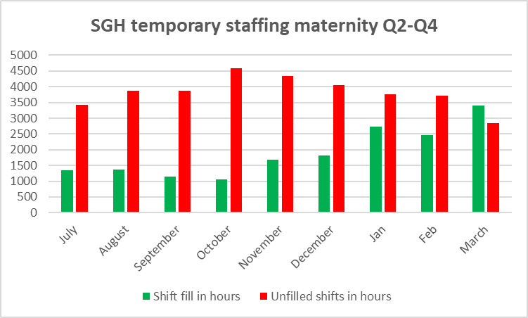

Scarborough’s fill rates have improved since January 2024. Like York, sickness rates have steadily improved since July. For this reporting period, sickness ranged from 2.62% (Community Midwifery) to 15.54% (Hawthorn), with the most common reason for sickness being cough, cold, ‘flu.
Scarborough shifts have traditionally been more challenging to cover due to the location, however, has improved from January with block booked agency staff. As demonstrated within the tables, there continues to be a significant number of unfilled shifts. We also acknowledge the number of vacant shifts covered, often by substantive staff, which places our staff at risk of the known effects of burnout.
Retention and recruitment midwives will provide monthly updates regarding vacancy and actions going forwards, which will inform workforce planning.
The Ward Managers and Matrons continue to receive support with roster management and key performance indicators: however, the vacancies have been so significant despite regular oversight there is limited opportunity to improve the position. Support is being provided in a variety of ways to include from the roster management team, the Workforce Lead, and the Interim Director of Midwifery.
When acuity and the staffing does not meet minimum safe staffing levels, a range of measures are taken in line with the maternity escalation policy such as:
- Request midwifery staff undertaking specialist roles to work clinically.
- Elective workload prioritised to maximise available staffing.
- Managers at Band 7 level and above work clinically.
- Re-allocate staffing to ensure one to one care in labour and where possible support the labour ward co-ordinator role to remain supernumerary is maintained.
- Activate the on-call midwives from inpatients / community to support labour ward.
All the above actions are designed to maximise staffing into critical functions to maintain safe care for the women and their babies. Historically, rosters have been created to have higher fill rates during the night shifts and weekends when there is less support available from specialist midwives and managers. Roster reviews have been more robust and managers trained in accordance with best practice; a further package of line manager training is planned for May 2024. Actions taken to support safe staffing are captured in the live birth rate plus acuity tool.
Band 7 managers and specialist midwives currently undertake a manger of the day role at each site, which supports escalation, staff breaks and patient flow. This role is highly valued, however removes mangers and specialists from their substantive roles. There is also evidence of significant variation in the quality on a day-to-day basis due to the variety of staff undertaking, without having formal training and role description. This role will be reviewed against recommendations for a dedicated flow midwife role as part of the Workforce Review.

- Birth to Midwife Ratio

The birth to midwife ratio is calculated monthly using Birth Rate Plus methodology and the actual monthly delivery rate. This has now been added to the maternity dashboard so that it can be monitored alongside clinical data. The table outlines the real time monthly birth to midwife ratio.

* This metric is calculated manually. It is noted that this figure includes whole time equivalent midwives employed by the Trust, but does not account for sickness, maternity leave, supernumerary status (international midwives) managers and specialist midwives. This calculation only counts the numbers of births and does not reflect the acuity of the women delivered.

Monthly births | Oct 23 | Nov 23 | Dec 23 | Jan 24 | Feb 24 | March 24
York | 228 | 244 | 222 | 222 | 214 | 213
Scarborough | 100 | 109 | 100 | 99 | 95 | 114

Monthly WTE | Oct 23 | Nov 23 | Dec 23 | Jan 24 | Feb 24 | March 24
York | 94.55 | * | 116.2 | 113.78 | 113.7 | 110.88
Scarborough | 39.71 | 55.37 | 55.37 | 55.3 | 55.35 | 55.35

Monthly Midwife  to Birth ratio | Oct 23 | Nov 23 | Dec 23 | Jan 24 | Feb 24 | March 24
York | 1:29 | * | 1:23 | 1:23 | 1:23 | 1:23
Scarborough | 1:30 | 1:20 | 1:22 | 1:22 | 1:21 | 1:25

Across the Trust this equates to:

 | Oct 23 | Nov 23 | Dec 23 | Jan 24 | Feb 24 | March 24
Ratio | 1:29 | * | 1:23 | 1:22 | 1:22 | 1:24
Births | 328 | 353 | 322 | 312 | 309 | 327

* Data not yet available
Midwife: Birth Ratio calculated as number of births x 12 / WTE midwives. This is not adjusted for staff absence such as sickness, maternity leave. The table below illustrates the impact of including unfilled shifts, plus the addition of shifts filled with temporary staff. This reflects a more realistic position.
 | Oct 23 | Nov 23 | Dec 23 | Jan 24 | Feb 24 | March 24
Ratio when unfilled shifts deducted and temp staffing added | 1:37 | * | 1:25 | 1:22 | 1:22 | 1:22
Births | 328 | 353 | 322 | 312 | 309 | 327

The impact of unfilled shifts (including vacancy, inadequate headroom, sickness and maternity leave) has been significant, reducing our midwife to birth ratio to less than 1:37. There is currently no national recommendation for birth to midwife ratio due to a rise in the acuity based within maternity services.

- Specialist Midwives

Birth Rate Plus recommends that 8-11% of the total establishment are not included in the clinical numbers, with a further recommendation of this being 11% for multi-sited Trusts. This includes management positions and specialist midwives. The current percentage for York and Scarborough is calculated to be 6.8%.

- Birth Rate Plus Live Acuity Tool

The Birth Rate Plus Live Acuity Tool was introduced in the intrapartum areas on both sites in April 2021 and on the other inpatient areas on June 2021. It is a tool for midwives to assess their ‘real time’ workload arising from the number of women needing care, and their condition on admission and during the processes of labour, delivery and postnatally. It is a measure of ‘acuity’, and the system is based upon an adaption of the same clinical indicators used in the well-established workforce planning system Birth Rate Plus.

The Birth Rate Plus classification system is a predictive/prospective tool rather than the retrospective assessment of process and outcome of labour used previously. The tool is completed four hourly by the labour ward co-ordinator. An assessment is produced on the number of midwives needed in each area to meet the needs of the women based on the minimum standard of one-to-one care in labour for all women and increased ratios of midwife time for women in the higher need categories. This provides an assessment on admission of where a woman fits within the identified Birth Rate Plus categories and alerts midwives when events during labour move her into a higher category and increased need of midwife support.

This safe staffing tool kit supports most of the components in the NICE Guidance 2017 (and is endorsed by NICE) on safe midwifery staffing for maternity settings necessary for the determination of maternity staffing requirements for establishment settings. It provides evidence of what actions are taken at times of higher acuity and use of the escalation policy when required.

The following provides evidence of actions taken (both clinical and management) to mitigate any shortfalls in staffing or for periods of high acuity.

York Q3

Data shows that actions were required on 56 occasions (14%), which is a reduction from Q2 (18%). These actions included delay in accepting transfers (n33), delay in induction activity (n16), decline in in-utero transfers (n5). Some women may have been affected by more than one clinical action.

York Q4

Data shows that actions were required on 33 occasions (8%), which is a further reduction from Q3 (14%). These actions included delay in accepting transfers (n22), delay in induction activity (n12), which demonstrates clinical activity is less impacted by poor staffing. Some women may have been affected by more than one clinical action.

Scarborough Q3

Data shows that actions were required on 16 occasions (4%). These actions included delay in induction activity (n14), delay in transfer to theatre (n1) and delay in in utero transfer (n1). Some women may have been affected by more than one clinical action.

Scarborough Q4

Data shows that actions were required on 14 occasions (3%), which a similar position to Q3 (4%). These actions included delay in induction activity (n12) and delay in transfer to theatre (n2). Some women may have been affected by more than one clinical action.

- Supernumerary Labour Ward Co-ordinator (LWC)

Availability of a supernumerary labour ward co-ordinator is recommended as an essential component of safe maternity care. This is an experienced midwife available to provide advice, support, and guidance to clinical staff and able to manage activity and workload through the labour ward. The impact of inadequate staffing, and lack of triage at SGH will need to be addressed to improve this. An action plan will be drafted to address non-compliance as per MIS guidance.

The following table outlines the compliance by month:

Site 1: York

York | Number of episodes non-supernumerary status per month | Number of shifts per month | Compliance
October 2023 | 0 | 62 | 100%
November 2023 | 0 | 60 | 100%
December 2023 | 0 | 62 | 100%
January 2024 | 0 | 62 | 100%
February 2024 | 0 | 58 | 100%
March 2024 | 0 | 62 | 100%
*NB. Data to be interpreted cautiously as the BirthRate+ Acuity tool is validated at data entry of 85%. For Q3 – Q4, data entry range is 69-77% across site.

Site 2: Scarborough

Scarborough | Number of episodes non-supernumerary status per month | Number of shifts per month | Compliance
October 2023 | 6 | 62 | 90%
November 2023 | 10 | 60 | 83%
December 2023 | 4 | 62 | 94%
January 2024 | 4 | 62 | 94%
February 2024 | 4 | 58 | 93%
March 2024 | 4 | 62 | 94%
*NB. Data to be interpreted cautiously as the BirthRate+ Acuity tool is validated at data entry of 85%. For Q3 – Q4, data entry range is 70-77% across site.

As demonstrated, SGH report non-compliance more frequently than York. In part this is due to not having a dedicated maternity triage which means the LWC regularly reviewed these attendees on labour ward.

- One to One in Established Labour

Women in established labour are required to have one to one care and support from an assigned midwife. One to one care will increase the likelihood of the woman having a ‘normal’ vaginal birth without interventions and will contribute to reducing both the length of labour and the number of operative deliveries. Care will not necessarily be given by the same midwife for the whole labour.

If there is an occasion where one to one care cannot be achieved, then this will prompt the labour ward co-ordinator to follow the course of actions within the acuity tool. These may be clinical, or management actions taken.

The following table outlines compliance by Month.

Site 1: York

York Q3 | Oct 2023 | Nov 2023 | Dec 2023
One to one Care in labour | 100% | 100% | 100%
York Q4 | Jan 2024 | Feb 2024 | March 2024
One to one Care in labour | 100% | 100% | 100%

Site 2: Scarborough

SGH Q3 | Oct 2023 | Nov 2023 | Dec 2023
One to one Care in labour | 100% | 100% | 100%
SGH Q4 | Jan 2024 | Feb 2024 | March 2024
One to one Care in labour | 100% | 100% | 100%

Both sites achieved 100% compliance across July-December 2023.

- Red Flag Incidents

A midwifery red flag event is a warning sign that something may be wrong with midwifery staffing (NICE 2015). If a midwifery red flag event occurs, the midwife in charge of the service is notified. The midwife in charge will then determine whether midwifery staffing is the cause and the action that is needed. Red flags are collected through the live Birth Rate Plus acuity tool.

The following tables articulates the red flag events

 | Red Flag Incidents
1 | Delayed or cancelled time critical activity
2 | Missed or delayed care (for example, delay of 60 minutes or more in washing and suturing)
3 | Missed medication during an admission to hospital or midwifery-led unit (for example, diabetes medication)
4 | Delay in providing pain relief  Delay of more than 30 minutes
5 | Delay between presentation and triage  Delay of 30 minutes or more
6 | Full clinical examination not carried out when presenting in labour
7 | Delay between admission for induction and beginning of process  Delay of 2 hours or more
8 | Delayed recognition of and action on abnormal vital signs (for example, sepsis or urine output)
9 | Any occasion when one midwife is not able to provide continuous one-to-one care and support to a woman during established labour
10 | Coordinator not able to maintain supernumerary/supervisory status

Ongoing work is taking place to support accurate data entry. Local red flag data is collected and reviewed monthly.
- Obstetric staffing

The rotas and skill mix on both sites for obstetric staffing are in line with RCOG guidelines for entrustability and include the use of locum staff where necessary to ensure rotas do not have gaps.
The summary of obstetric staffing across both sites is summarised below:
York |  |  |  | Scarborough
 | No. of Drs | WTE |  |  | No. of Drs | WTE
Tier 1 (ST1-3) | 10 |  |  | Tier 1 (ST1-3) | 8 | 8
Tier 2 (ST4-ST8) | 12* |  |  | Tier 2 (ST4-ST8) | 7^^ | 7
Tier 3 (Consultant) | 15 | 14.7 |  | Tier 3 (Consultant) | 9** | 8.5
* includes 1 Speciality dr |  |  |  | ^^ includes 2 Specialty drs and 2 locum drs
 |  |  |  | ** includes 2 Consultants working cross-site

Following a review of the Obstetric Medical Workforce, two vacant Obstetric Consultant posts (1xYork, 1xSGH) have been appointed to with an anticipated start date of September 2024.

The Temporary Staffing Team are currently manually checking applications to ensure the criteria for employing short-term locum medical staff in Obstetrics and Gynaecology on Tier 2 or 3 (middle grade) rotas are met. This includes a check of their GMC registration and their RCOG CEL. For those who do not hold a CEL, the induvial is asked to supply evidence which is submitted to the appointing consultant for review.
Criteria:
a. currently work in their unit on the Tier 2 or 3 rota
or
b. have worked in their unit within the last 5 years on the Tier 2 or 3 (middle
grade) rota as a postgraduate doctor in training and remain in the
training programme with satisfactory Annual Review of Competency
Progressions (ARCP)
or
c. hold a certificate of eligibility (CEL) to undertake short-term locums.

Moving forward, vacancies will be advertised on Trac. The Temporary Staffing Team are looking to adopt a more robust process for and continue to work with Trac to explore the feasibility of incorporate the criteria questions into the application form. Once agreed, an SOP will be developed to support business continuity. The team also expect to go-live with BankStaff+ in July 2024, moving away from Patchwork.

On-boarding of locum medical staff is overseen by the Trust Medical Staffing team. The current SOP is under review to ensure the Monitoring and effectiveness tool is adopted into working practice. In addition, the requirement to conduct a 6-monthly audit on the monitoring and effectiveness tool is being discussed.

From January to May 2024 there were only two locums used by the obstetric service

The non-resident on-call out of hours Consultants and senior Speciality, Associate Specialist and Specialist (SAS) doctors will come to site if there are gaps which cannot be mitigated with locum staff; their time is then compensated. We are usually able to support compensatory rest as all job plans have been designed with this in mind.

There are ongoing discussions to support the development of a Compensatory Rest SOP.
The rota is audited bi-annually by the Obstetric and Gynaecology operational team. The rotas for January to March 2024 have been reviewed and audited; there are no recorded incidents of uncompensated rest periods for non-resident staff after a night on call.

Compliance of consultant attendance for the clinical situations listed in the RCOG workforce document: ‘Roles and responsibilities of the consultant providing acute care in obstetrics and gynaecology’ is recorded in a 3x daily handover book. Episodes where attendance has not been possible are reviewed at Maternity Case Review (MCR) meeting thrice weekly as an opportunity for departmental learning, with agreed strategies and action plans implemented to prevent further non-attendance.

- Anaesthetic staffing

The trust can confirm that there is a duty anaesthetist immediately available for the obstetric unit 24 hours a day and the unit has clear lines of communication to the supervising anaesthetic consultant at all times. Where the duty anaesthetist has other responsibilities, they are able to delegate care of their non-obstetric patients in order to be able to attend immediately to obstetric patients in line with ACSA standard 1.7.2.1. The anaesthetic rotas for the period October 2023 to March 2024 have been reviewed and audited and this demonstrates 100% compliance.

- Neonatal medical staffing

To meet Safety Action 4 of the Maternity Incentive Scheme (MIS), the Trust is required to demonstrate compliance against British Association of Perinatal Medicine (BAPM) national standards for neonatal medical staffing. If the standards are not met, the Trust is required to produce an action plan and detail progress against any previously developed action plans. The Trust must share action plans with the LMNS and Neonatal Operational Delivery Network (ODN) for oversight.

Staffing requirements for York LNU:

- Tier 1: Rotas should be EWTD compliant and have a minimum of 8 WTE staff who do not cover general paediatrics in addition.
- Tier 2: Shared rota with paediatrics as determined by a Trust or Health Board’s annual NNU activity, comprising a minimum of 8 WTE staff.
- Tier 3: A minimum of 7 WTE neonatal paediatricians/neonatal consultants on the on-call rota. Minimum of 1 consultant with a designated lead interest in neonatology.

Tier 1 staffing position York
BAPM guidance recommends that a Tier 1 Neonatal Doctor who is dedicated to providing emergency care to the neonatal service is available 24/7. Currently, during weekdays, there is dedicated neonatal daytime cover from 09:00-22:00 but overnight there is a single Tier 1 Doctor who covers both Paediatrics and Neonates. Additionally at weekends, there is a single Tier 1 doctor covering Paediatrics and Neonates from 17:00-09:00. During the daytime, the neonatal unit Tier 1 Doctor is usually the first to get reallocated should there be rota gaps.

The current rota will be adjusted from August 2024 to provide a second Tier 1 Doctor on long days at weekends providing additional cover between 17:00-22:00 however this does not address the overnight deficit. To achieve compliance against BAPM staffing standards, 2x additional Tier 1 Doctors are required. A business case will need to developed and extra funding provided to meet this requirement.

Rotas are complaint with the European Working Time Directive.

There are ongoing discussions regarding midwives completing the newborn examinations (NIPE) which will release a Tier 1 doctor during the day who could then support the neonatal service. It might be possible to adjust the current Tier 1 rota and not need additional doctors if NIPEs could be completed by midwives. Progress against this ambition is reliant on approval of the midwifery workforce business case which was submitted to the ICB for approval.

Tier 2 staffing position York
Based on the unit’s activity, it is recognised that 2x additional Tier 2 Doctors are required to sufficiently adjust the rota and provide dedicated emergency cover to the neonatal service during its busiest periods. Weekend twilight rota gaps remain an ongoing issue and are currently mitigated through the use of locums. Following a successful action plan submission to the Neonatal Operational Delivery Network (ODN), £62,500 was awarded recurrently to support recruitment of additional medical staff in York; A business case has been submitted to utilise this funding and is being progressed within the Trust. This will still leave a gap of 1 WTE Tier 2 post to achieve BAPM compliance; A business case is currently being developed which outlines further investment required to recruit to this position.

Tier 3 staffing position York
There are 10 WTE consultants on the Tier 3 on-call rota of which 1 consultant has a designated lead interest in neonatology. All Tier 3 consultants have a CCT in paediatrics or CESR in paediatrics or an equivalent overseas neonatal or paediatric qualification.

As part of the annual appraisal and revalidation process, all consultants covering the service must demonstrate expertise in neonatal care (based on training, experience, CPD and on-going appraisal).

There is an additional requirement that at least one LNU Tier 3 consultant should have either a CCT in neonatal medicine or neonatal SPIN module. The dedicated neonatal lead has SPIN equivalent training but not a recognised SPIN qualification. We are currently awaiting input from the ODN regarding this recommendation.

Tier 1 staffing position Scarborough

Currently, during weekdays, there is dedicated neonatal daytime cover from 09:00-1700 however after 17:00, overnight and during weekends there is a single Tier 1 doctor who covers both Paediatrics and Neonates. Tier 1 is staffed by a team from FYs/GP trainees/ Paediatric Trainees and SAS.

Rotas are compliant with the European Working Time Directive.

Discussions are ongoing regarding midwives completing the newborn examinations (NIPE) during the week including the weekends which will release a Tier 1 doctor during the day particularly during the weekends when only Tier 1 doctor is available who could then support the neonatal / Paediatric services locum cover for 2 hours during the weekend by tier 1 doctors have been tried for nearly 2 months to complete the NIPE and discharge babies early this was stopped with the expectation that trained midwives could be able to provide this service soon.

Tier 3 staffing position Scarborough

There are 8 WTE tier 2 doctors that include Paediatric trainees/ SAS ( Speciality and specialist doctors (2 SAS have indicated that they will leave but they haven't yet submitted their notices with leaving dates and they will need to be replaced). Tier 2 doctors do cover both Paediatrics and neonates, the staffing cover and rotas are compliant with BAPM recommendations.

Tier 3 staffing position Scarborough

There are 8 WTE consultants including a locum consultant 3 substantive consultants have recently been appointed all have received CCT (certificate of completion of training) and are on specialist register for Paediatrics. One consultant has an interest in neonatology and all consultants cover the paediatric and neonatal rota and the on calls. All consultants continue to maintain up to date knowledge, skills and CPD suitable for the level of neonatal care and undergo assessment at the annual appraisal. The tier 3 staffing cover and the required skills are both compliant with BAPM recommendations.

- Neonatal Nursing Staffing

To meet Safety Action 4 of the Maternity Incentive Scheme (MIS) the neonatal unit needs to demonstrate that it meets the service specification for neonatal nursing standards.

The Neonatal Service is required to formally report to the Trust Board its compliance annually with regards to BAPM nurse staffing standards using the Neonatal Nursing Workforce Calculator (2020) (Dinning Tool). For neonatal units that do not meet the standard, the Trust Board should agree an action plan and evidence progress against any action plan previously developed to address deficiencies. A copy of the action plan, outlining progress against each of the actions, should be submitted to the LMNS and Neonatal Operational Delivery Network (ODN). The Trust declared non-compliance with MIS Year 5, Safety Action 4 and a subsequent action plan produced and submitted to the LMNS and NHS Resolution for approval.

The BAPM nurse staffing tool is completed every three months for Neonatal Services cross site. The Trust was below the national 70% Qualified in Speciality (QIS) compliance requirement during Q3 & Q4 2023/24.

In York, one registered nurse (RN) is predicted to qualify in speciality during Q1 2024/25 and the newly appointed Neonatal RN is already qualified; therefore, achieving the 70% compliance requirement at York. In Scarborough, 2 RN’s are predicted to qualify in speciality during Q1 2024/25 the site is therefore predicted to achieve the 70% compliance requirement from Q2 2024 onwards.

There are currently three Band 3 staff undertaking the Trainee Nurse Associate (TNA) course: 1 qualifying in June 2024 and 2 in June 2026. Once registered, these staff members will support the delivery of Transitional Care as registered Nursing Associates Band 4 in York and Scarborough.

One Band 4 Associate Practitioner in Scarborough is currently undertaking the Registered Nurse Training Degree and will qualify in July 2024. There is currently no vacant position a to support this individual as a Band 5 RN in Neonates in Scarborough.

In addition to the calculated number of neonatal nurses required, there should be a shift coordinator for every shift 24/7, as described in section 5.6 ‘Additional Nursing Roles outlined in BAPM Service and Quality Standards for Provision of Neonatal Care in the UK’. There is no current budget for this role and is reflected in the Dinning Tool calculations.

A planned Neonatal Workforce review in collaboration with Human Resources, led by the Associate Chief Nurse, Neonatal Cross-Site Lead and Interim Head of Childrens Nursing is planned to commence in Q1 2024. Findings of the review will be triangulated with the outputs of the neonatal workforce calculator figures (Dinning Tool) and BAPM Champions for the Quality of Practice within each unit. Additionally, the BAPM Service and Quality Standards for Provision of Neonatal Care in the UK recommends an uplift of 25% to support staff over and above direct clinical care. Currently, nursing staff headroom is at 20%. A business case may be required should additional funding be required to support staffing levels and service improvement requirements such as the implementation of Transitional Care on both sites.

There is recognition that additional funding is required to support the ongoing work currently undertaken to achieve compliance with BFI, BLISS and UNICEF; allocated hours are currently a cost pressure to the unit. Requirements will be explored during the Workforce Review.

A Band 7 Nurse Educator supports nurse education, preceptorship, foundation pathway, overview of TNA training and annual staff updates to include journal club, Neonatal Life Support (NLS) and Baby Friendly Initiative (BFI). They also lead on BFI Accreditation cross-site which includes medical and nurse training to support parent audits, staff audits, and meetings with UNICEF. In addition, the nurse educator attends, contributes and disseminates any learning or actions from steering groups with the ODN and the Trust e.g. Local Safety Standards for Invasive Procedures (LOCSSIPS), Early Expressing Breast Milk (EBM) and pressure ulcer improvement group. They also conduct audits, delivers NLS to emergency department nurses, attends Avoid Term Admissions Into Neonatal units (ATAIN) meetings cross site and ODN meetings throughout the year. Funding has been awarded to support 0.45 of a Band 6 Governance Nurse and utilisation of this funding will be discussed during the Workforce Review.

York staffing review summary Q3 2023/24

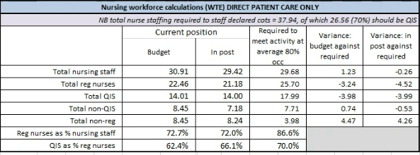

York staffing review summary Q4 2023/24

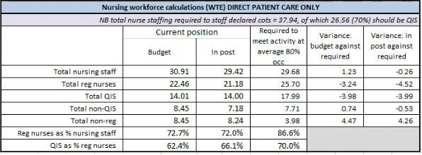

Scarborough staffing review summary Q3 2023/24

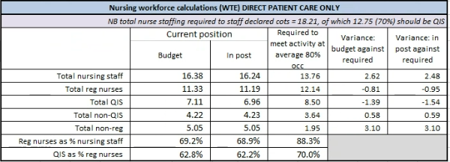

Scarborough staffing review summary Q4 2023/24

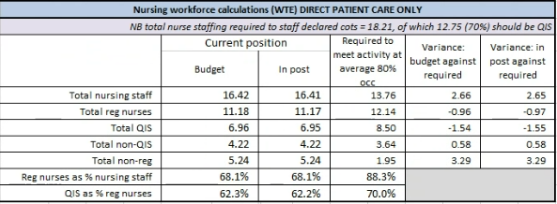

- Recommendations

The Resource Committee is asked to note the contents of the report and formally record to the Trust Board minutes compliance with BAPM standards for both neonatal nurse staffing and neonatal medical workforce if compliance is met or agree to the action plan if not met.

