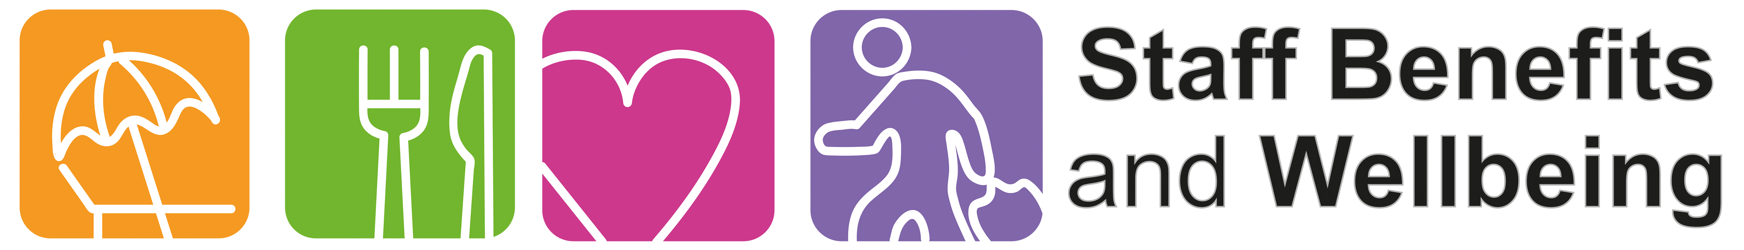

Staff Benefits Grants
Application Form

The Physical Activity Grant (annual)
For individuals starting a NEW physical activity such as running, walking, swimming, fitness classes (this grant cannot be used to fund an existing physical activity that the applicant regularly participates in). The maximum amount available to claim is £25. A receipt must be attached to this form and the grant payment will be made through salary.

Weight Management Grant (annual)
This grant is available for an individual to join a weight management group such as Slimming World, Weight Watchers, or any other weight management group/app. The total amount available to claim is £25. A receipt must be attached to this form and the grant payment will be made through salary.

Enhancing Your Work Environment Grant (one off)
This grant offers staff the opportunity to request funding that will help towards enhancing the work environment. These would be items not normally provided through Trust budgets such as cups, cutlery, plants, and pictures. The total amount for an individual grant is £25 per team. The requested items will be purchased for you by Staff Benefits.

The following criteria will pertain to all funding requests:
- You must be currently employed by York and Scarborough Teaching Hospitals NHS Foundation Trust or York Teaching Hospital Facilities Management.
- An application form must be completed for each grant.
- Receipts must be dated in the month you apply for the grant (with the exception environment grant).
- The following are examples of what cannot be requested (please note this list is not exhaustive):
  - Items needing on-going maintenance.
  - Food items.
  - Electrical items.
  - Display Screen Equipment.
  - Trainers.
  - Fitness monitors.
- Staff Benefits have the right to refuse any request.

Please complete all the fields requested below.

Which grant would you like to apply for?
Mark box with an X

Physical Activity Grant (up to £25)
A receipt must be attached to this form
Weight Management Grant (up to £25)
A receipt must be attached to this form
Enhancing Your Work Environment Grant (up to £25)
No receipt required

Your details

Name (Full Name)
Department
Work base
Contact Number
Email (Trust email preferred)
Assignment Number
(Found on your wage slip)

What is the grant for?
Please give brief description of which company or physcial activity grant is for. If applying for the environment grant please include links to websites and full description if what is required:

Type here…

Check the above, sign and date.
By signing the below, you agree you have read the grant criteria specified above.

Signature
Date

Once complete, please email this application to yhs-tr.staffbenefits@nhs.net

Office Use Only
This section is for the Staff Benefits team to complete

Authorisation Signature |  | Date |  | Total to be refunded

