GP Requesting & Reporting
for EMIS

ICE

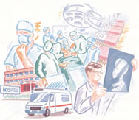

IT Training Department

Contents

IMPORTANT NOTICE 3
Log onto Emis 4
Electronic Requesting 4
Edit Patient Requests 8
View Patients Results 10
Cumulative View 13
Graphing Results 14

IMPORTANT NOTICE

You must not handwrite results from this system. All results must be printed out. If you do not have access to a printer you should not be using ICE!

All printouts from ICE must be treated as Confidential Waste ie these reports must be either shredded or incinerated and not placed in the wastepaper basket.

- Users must log on using their own personal Username and password. These should not be shared with any other staff member.
- ICE Desktop reporting is fully auditable and all actions and enquires are recorded.

Log onto Emis

Electronic Requesting

Search for a patient (F5).

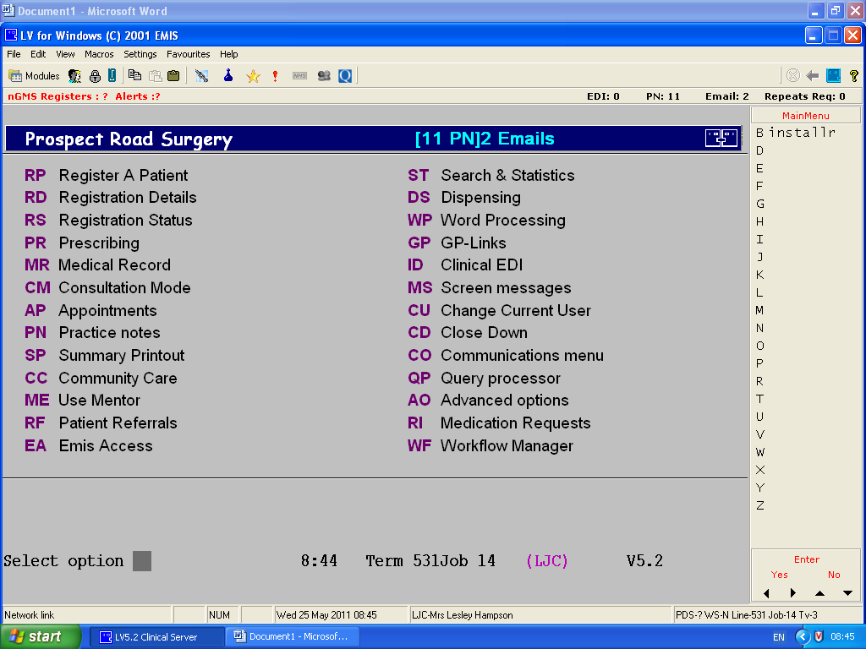

The patient’s details are shown at the top of the screen. Check these are correct before proceeding.

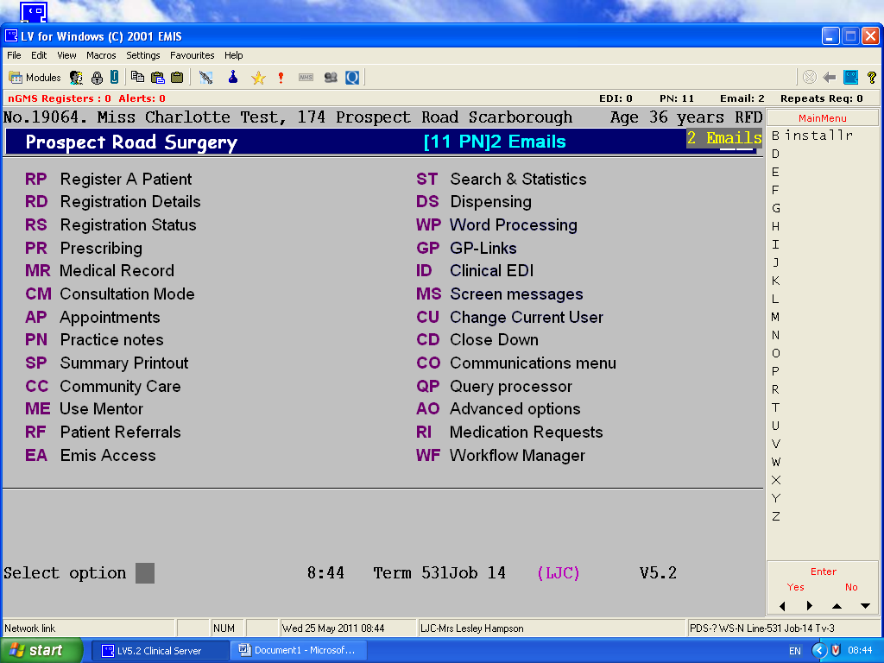

Type CM for Consultation Mode.

(Click F1 to get back to the main menu )

Consultation Mode View

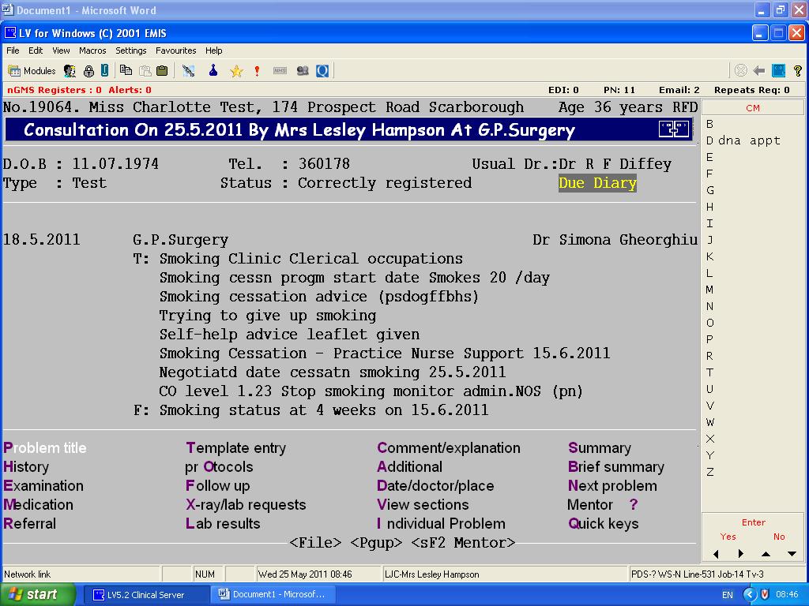

Type X for lab requests

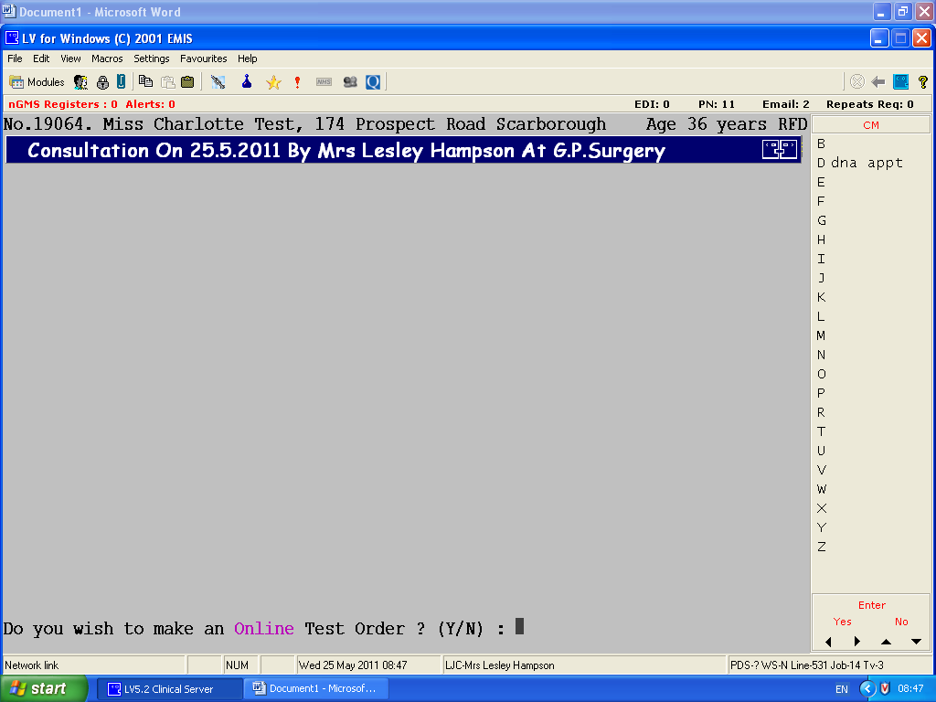

Type Y to make an online test order

This screen shows (in the first instance) the most commonly requested tests (and is under the tab on the left hand side marked ‘common tests’) – note the scroll bar on the right.
Other tests can be found under the relevant tab on the left hand side – if you don’t know which heading your test is under use the search facility.

The bottom part of the screen shows all tests previously requested and will build up a history in time.

To view all results including those tests carried out by the hospital (very useful) select ‘services’ from the top left of the screen – patient report list

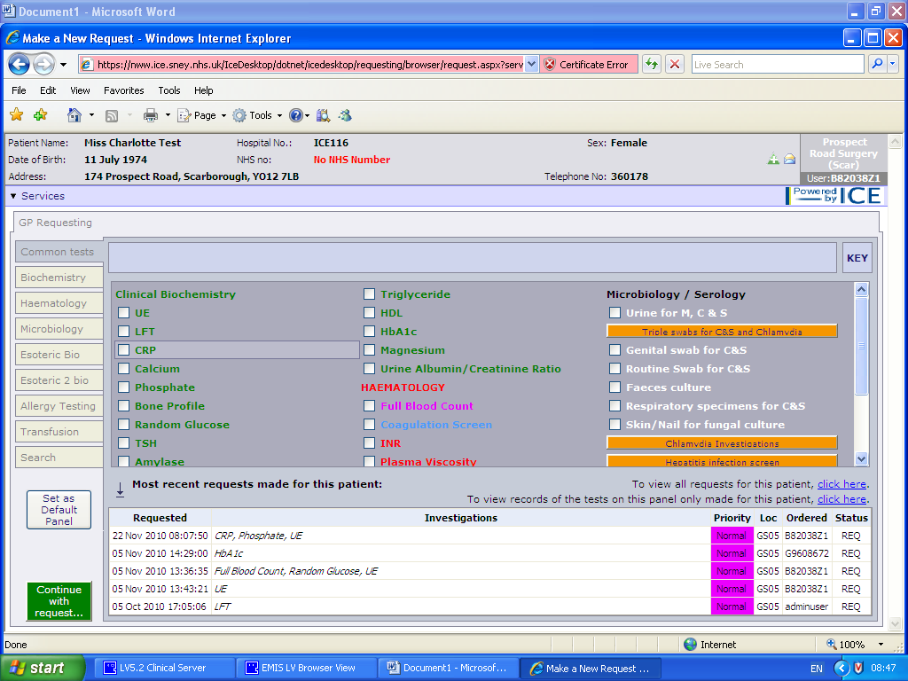
Click here to see all test results and all requests for your patient
Search facility
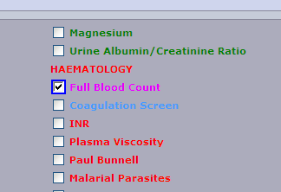
Select the tests you require

Follow any instructions that may appear
Then click ‘Continue with request’ button 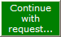

Complete the following fields:

- Requesting Consultant/GP – select from drop down list
- Global Clinical details – as you would have written on the paper form
- Unless you are making the request at the same time as taking the bloods put a tick in ‘I want to fill out specimen details later’ – this is to ensure the form and labels have the correct date and time on them when sending the sample off.
- If a Doctor wished to create the request for the sample to be taken later they must select ‘I want to fill out specimen details later’ – this will put an entry into the patient record for the phlebotomist to pick up later.

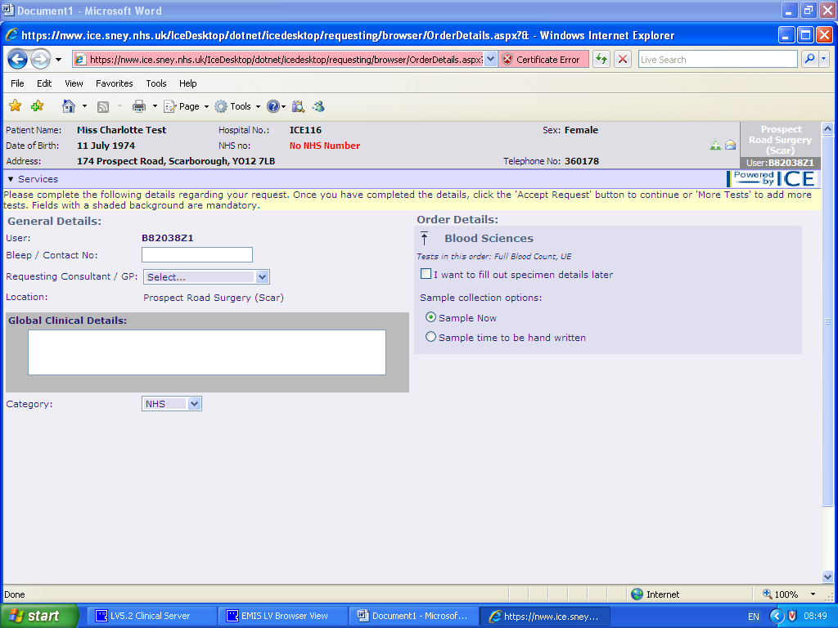
If you are taking the sample at the same time as creating the request: ensure Sample Now is selected.

If applicable, tick ‘yes’ or ‘no’ against risk of infection.
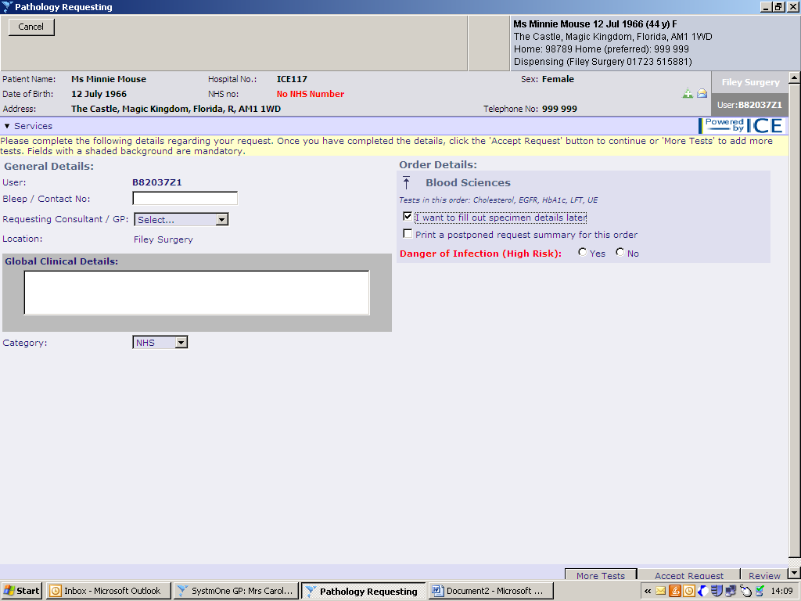

Accept Request
To accept the request use button at bottom of the screen

To print the forms and labels (both on an A4 sheet) select print for your default printer. Ensure that the form has printed correctly before selecting ‘proceed’ or otherwise select reprint before proceeding.

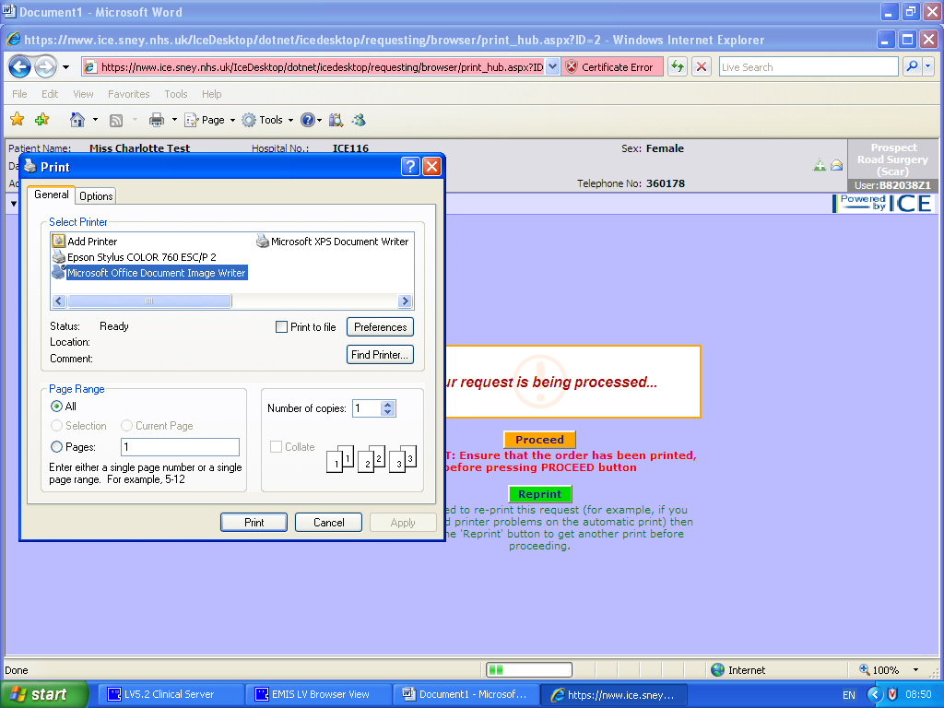

After printing, the EMIS record will be updated to show that the test has now been requested (with sample sent off).

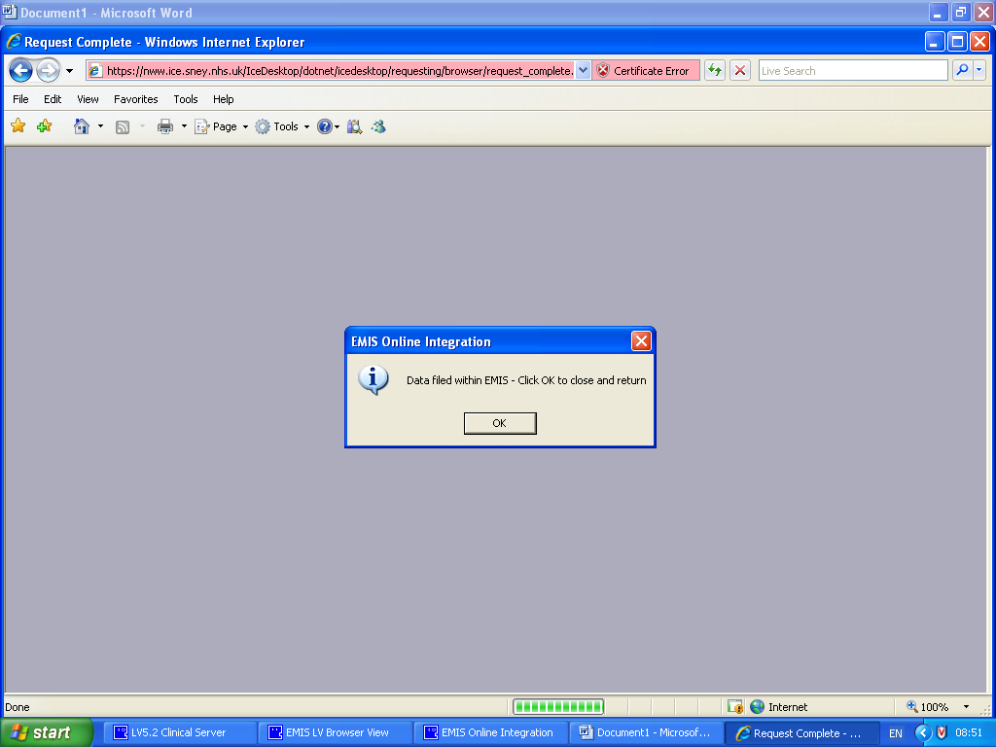

Edit Patient Requests

If you choose ‘I want to fill out specimen details later’ option the sample taker will need to follow the same requesting process within Emis.

To take the sample of a postponed request or edit, delete and view the audit trail of the patient requests.

Click on services then select patient request list.

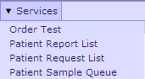
Select Patient Request List

The patient request list will be displayed, showing all requested and postponed pathology requests.

Click on the required pathology request, to view options available.
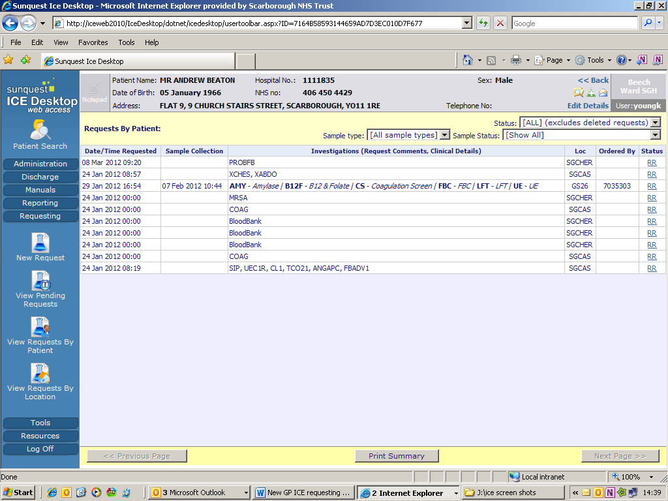

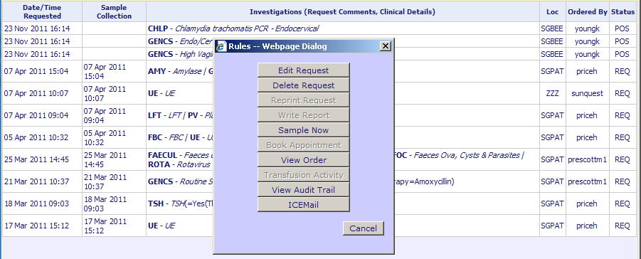

Edit Request: Can open the request and make changes.

Delete Request: Will delete the request from the ICE system (the deleted request will be available to view from sample status.
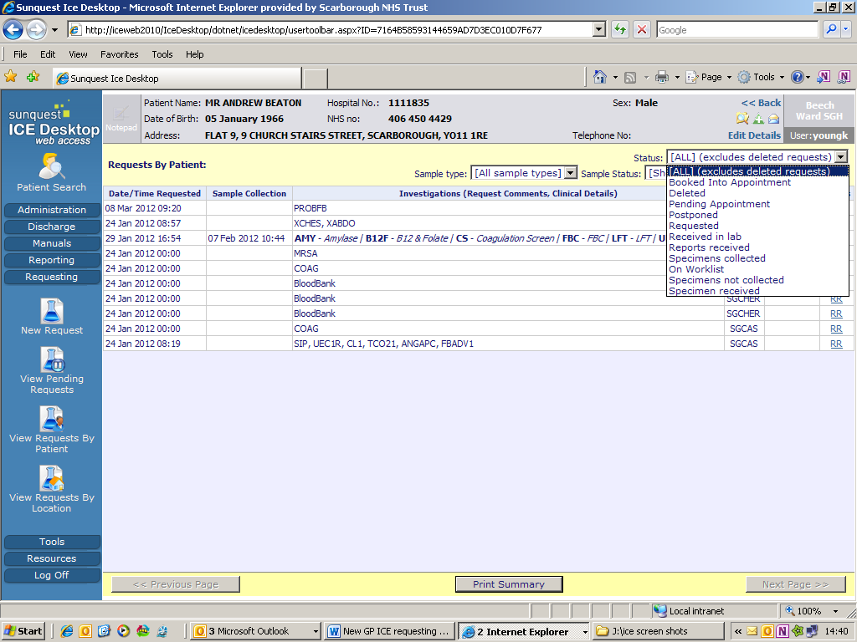

Reprint Request: Will reprint any request already printed

Sample Now: Take the sample of a postponed request

View Audit Trail: View the full audit trail of the request

View Patients Results

Navigate back to the Clinical Record MR

Type N for investigations

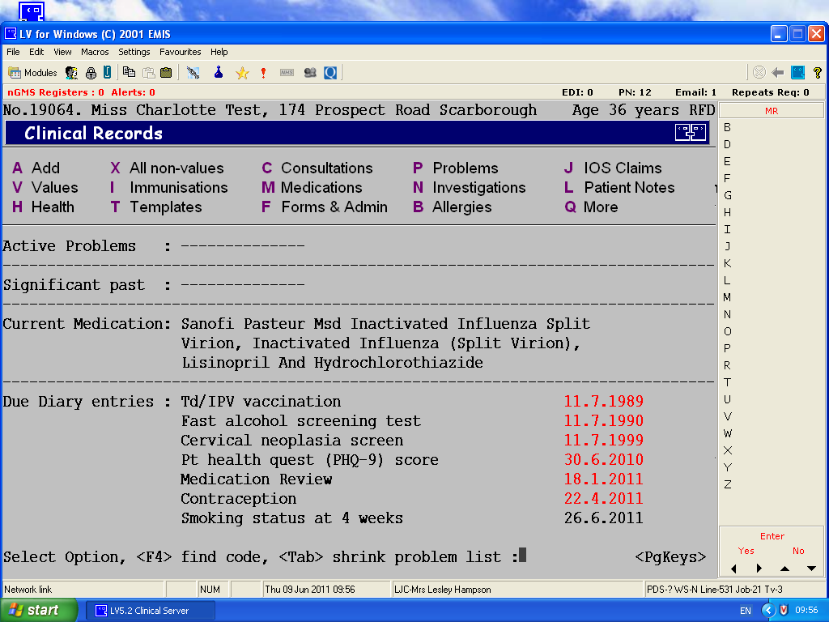

The Pathology Display Groups Screen is displayed

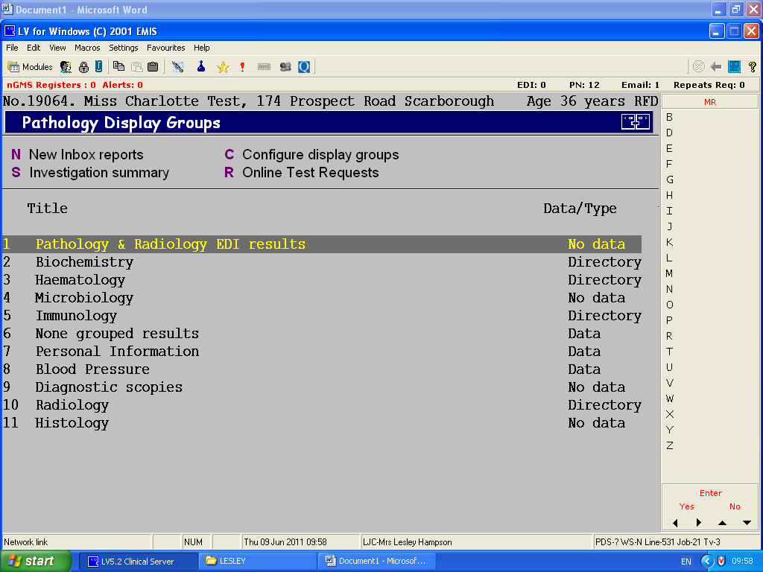

To Display the On Line Test Ordering Screen, Select R (Online Test Request)

To Display the ICE Desktop Location Screen, select T to show an individual patient report (Patient Report)

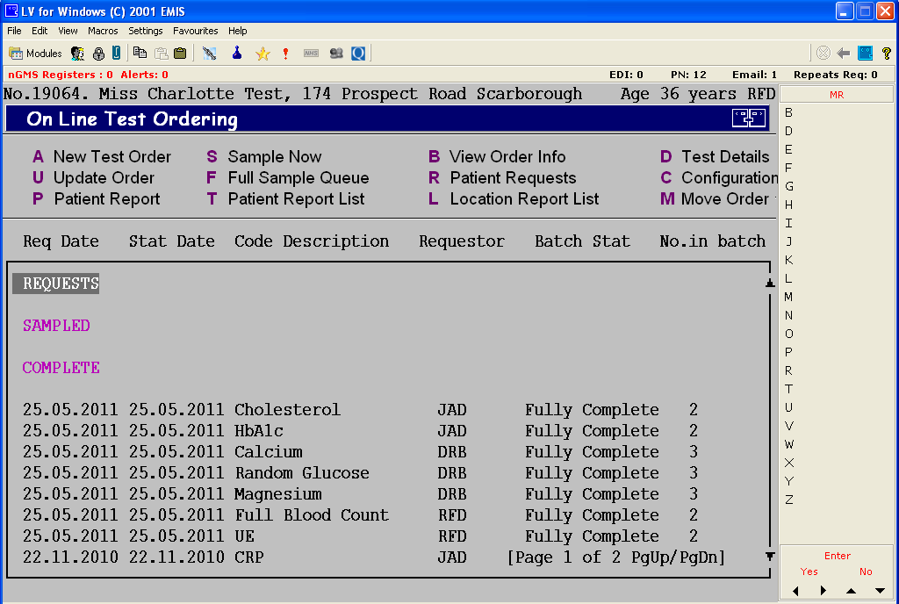

Select L to show all location reports (Location Report List)

This will launch the web Ice Desktop

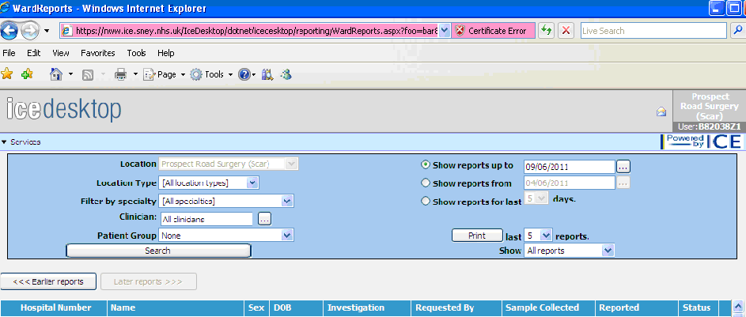

Your location is set to your GP Practice with the Clinician filter defaulting to all clinicians
If you want to filter by a specific clinician you can change

A list of patients from your GP Practice will be displayed.

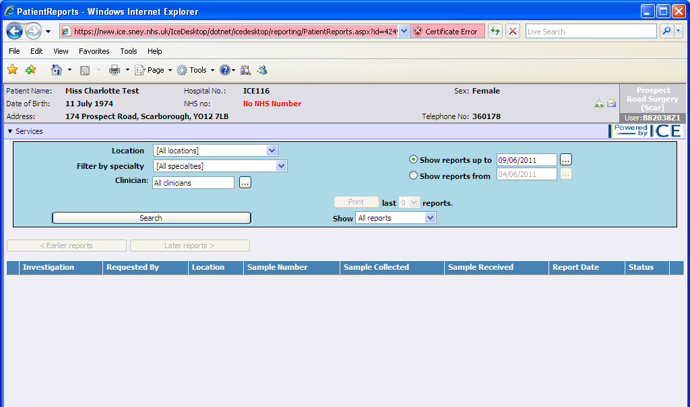

Click on your patient to view all the pathology and radiology reports (Hospital and GP)

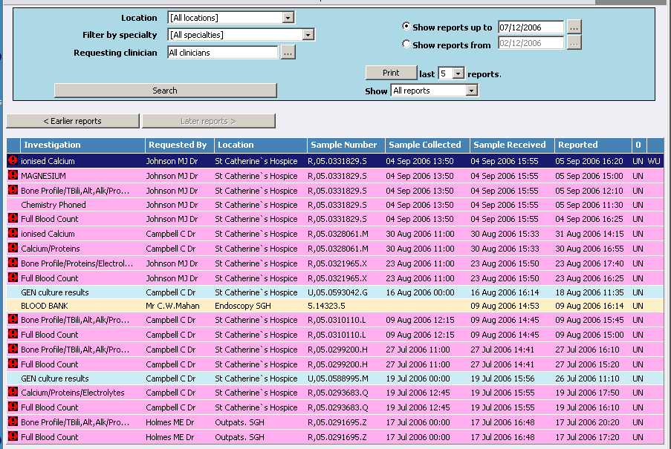

Once you have clicked to select a result it will be displayed on your screen. Check the patient details at the top are for the correct patient.

Previous & next report buttons (for the same patient)
Prints the report
Takes you back to the previous screen

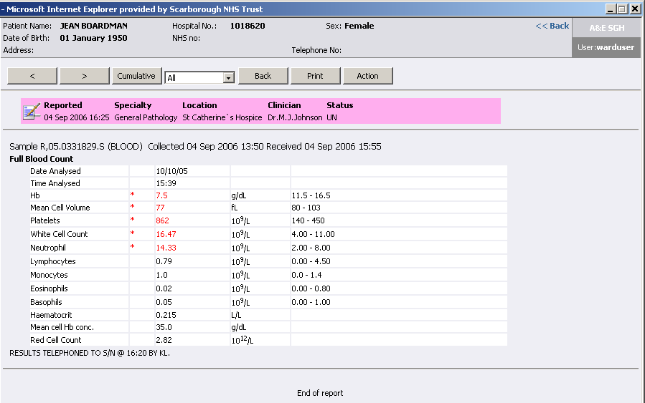

If you print out a copy of a report please be aware that this is only a working copy and is not to replace the report issued by the Pathology/Radiology department. Once you have finished with your printout it should either be shredded or incinerated in line with Patient Confidentiality procedures, please check what these procedures are in your area.

Cumulative View

You can view the cumulative view either by an individual result e.g. just Hb or a list of all results the patient has had reported.

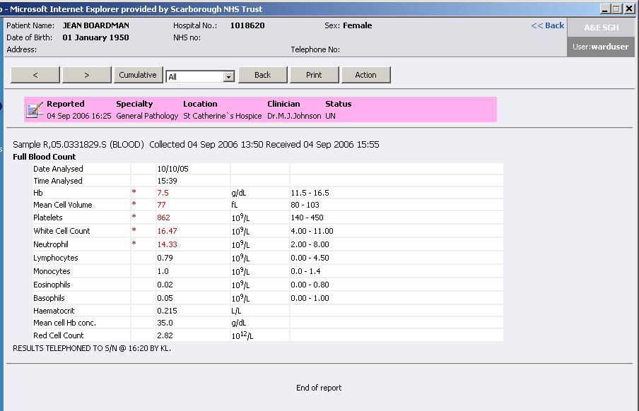
Click on the individual test name to view a cumulative view of that one type of result.
Click on ‘Cumulative’ button to view a cumulative view of all the patient results.

In report view click on the individual element you would like to see the cumulative view of, a list of all those type of results will be displayed in date order.

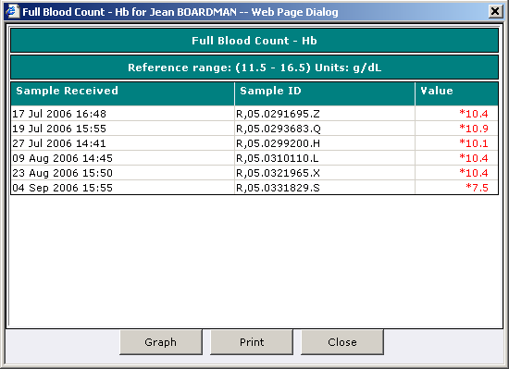

To view a cumulative view of all the results for a patient, click on the ‘Cumulative’ button, this will include results which are not in your current view. The results are displayed in a table format, the newest result is displayed in the first column.

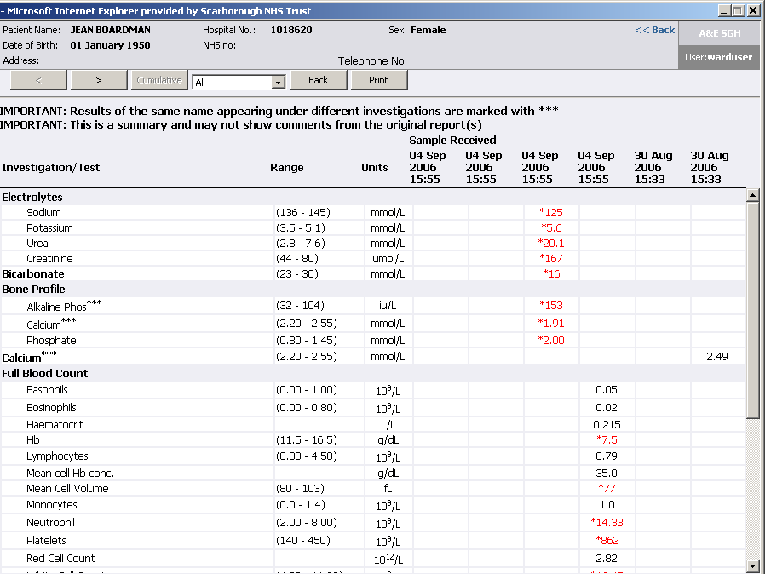

Once in Cumulative view you can also click on an individual result for a cumulative list of that one specific type of result.

Graphing Results

You can create a graph of the results by clicking on the ‘Graph’ button at the bottom of the individual cumulative view.

Example of a Graph

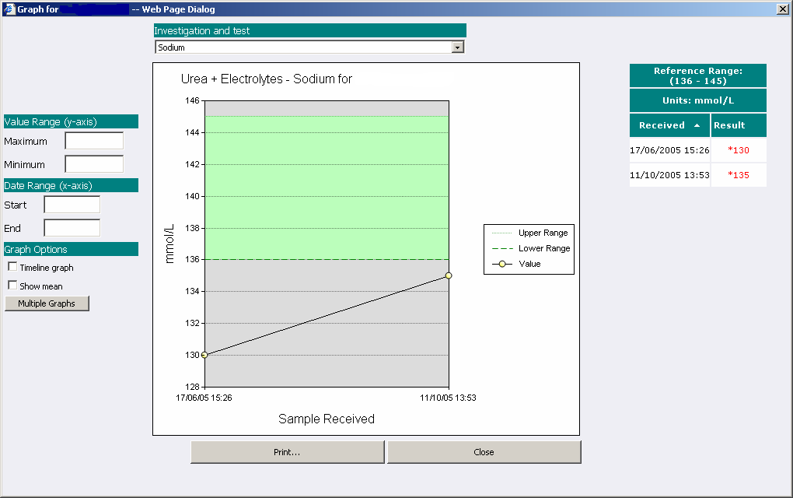

From this screen we can change graph type, change to multiple graphs or print.

Example of a Multiple Graph

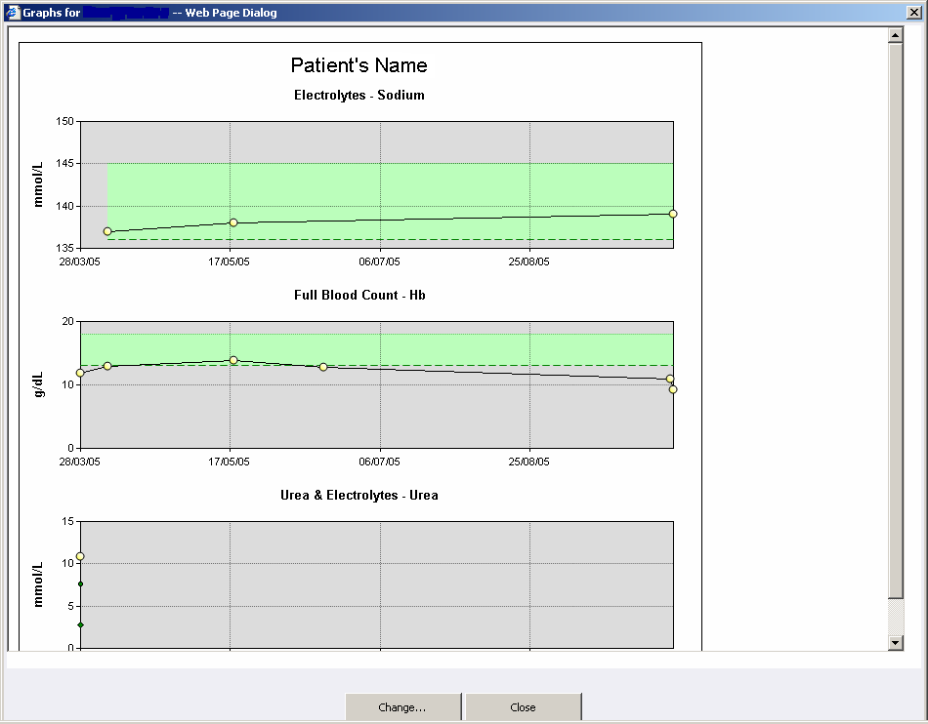

To close web ICE Desktop click on the X in the top right corner of the webpage.

The On line Test Ordering screen will be displayed.

