POCT Link Trainer Guide – ketone training

This document summarises the key points which should be covered by link trainers during training of POCT ketone testing using the Nova ketone meter.

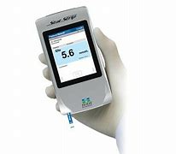  Purpose | - The ketone meter is utilised to measure ketone levels in blood samples. It is used in monitoring ketosis.
Sample requirements | - A fresh capillary or venous sample is required.  - Ketone tests should ONLY be run on the following patients:  - Type 1 diabetic with blood glucose >16mmol/L.  - Type 2 diabetic with blood glucose >16mmol/L AND seriously clinically unwell or NEWS2 >4.  - Pregnant patients with a blood glucose >10mmol/L.
Quality Control / EQA | - Two levels of QC must be analysed every 24 hours or if patient results are unexpected or the meter has been dropped/damaged.  - Once opened QC liquids are valid for 90 days.  - If a QC fails, try the following:  - Gently invert the liquid QC and ensure the correct level is being used.  - If that fails, try new QC liquids.  - If that fails, try a new pot of strips.  - If all the above fail, contact POCT.  - EQA samples should be tested on receipt, and the results returned to POCT on the form provided, as soon as possible.
Patient / sample preparation | - Gain positive patient identification and (when possible) consent.  - Wear the appropriate PPE.  - Wash and dry the patient’s hand thoroughly using warm water / soap warm water, NOT alcohol wipes/gel.  - Lance the finger on the side of the pad, no lower than the nail bed, then gently massage along the finger to obtain a blood drop. Do not squeeze the finger.
Analysis | - Logon to the meter and press the ‘accept’ button.  - Scan the strip lots then enter the patient ID.  - Insert the strip into the meter then prepare the patient as described in the section above.  - Touch the end of the strip on to the drop of blood. Results will appear after a 10 second countdown.
Results | - Results are displayed on the screen after analysis has been completed.  - Results are automatically transferred to patient records, but also should be documented in the patient’s notes.
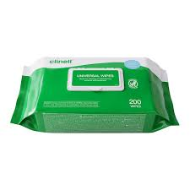  After testing | - Dispose of test strips and lancets following waste management guidance.  - The analyser can be cleaned with Clinell wipes after each use.
Stock | - Test strips are ordered from pharmacy.  - QC liquids are provided by POCT.
Analyser issues | - Contact POCT:  - York (772)5890  - Scarborough (771)2659  - Bridlington (771) 3321
* DO NOT SHARE YOUR OPERATOR ID WITH ANYONE *
* IT IS A DISCIPLINARY OFFENCE *

