

**Item 12**

|  |  |
| --- | --- |
| **Report to:** | Trust Board |
| **Date of Meeting:** | 26th June 2024 |
| **Subject:** | Maternity Neonatal Safety Report |
| **Director Sponsor:** | Dawn Parkes Interim Executive Chief Nurse (Maternity Safety Champion) |
| **Author:** | Sascha Wells-Munro, Director of Midiwfery Strategic Clinical Lead for Family Health |

|  |
| --- |
| **Status of the Report** (please click on the appropriate box)  Approve  Discuss  Assurance  Information  A Regulatory Requirement |

|  |  |
| --- | --- |
| **Trust Priorities**  Our People  Quality and Safety  Elective Recovery  Acute Flow | **Board Assurance Framework**  Quality Standards  Workforce  Safety Standards  Financial  Performance Targets  DIS Service Standards  Integrated Care System  Sustainability |

|  |
| --- |
| **Summary of Report and Key Points to highlight:**  This report provides an update on the progress of improvements in the maternity and neonatal service as well as provide monthly key quality and safety metrics for the services for the month of March 2024.  **Recommendation:**  The Board is asked to receive the updates from the maternity and neonatal service for March and approve the CQC section 31 report before submission to the CQC. |

|  |  |  |
| --- | --- | --- |
| **Report History**  The Quality and Safety Committee 20/02/2024 | | |
| **Meeting** | **Date** | **Outcome/Recommendation** |
| Quality & Safety Assurance Committee | 21/05/24 | 1/ To note the progress with the safety actions and improvement work in maternity and neonatal services.  2/ To formally receive and approve the CQC Section 31 monthly report.  3/ To formally receive and approve Bi-Annual maternity staffing report |

**Report to Trust Board**

The maternity and neonatal services continue to review and monitor improvements in key quality and safety metrics.

Annex 1 provides the current delivery position for the service against the core national safety metrics. In April 2024 there were two stillbirths both have been reported to MBRACE-UK and will be reviewed using the national Perinatal Mortality review Tool (PMRT). The families will be involved in this review to ensure all their questions and any concerns they may have, are addressed in full and that all the key opportunities for leaning and improvement are identified with clearly defined SMART actions taken. There were three reportable neonatal deaths in the service. After the initial review of all cases no immediate safety concerns in care were identified but all cases are subject to a PMRT review to ensure all learning opportunities are identified and will be shared with the families once complete.

There has been a decrease in the % of postpartum haemorrhage over 1500mls to 3.6% (11 cases) from the previous month of 4.3 % (14 cases). This remains above the national target of 2.9% per 1000 births. A Multi-professional focus group continues and a thematic review of 49 cases from November 2023 to the end of April 2024. The findings of this review will be shared in a MDT cluster review meeting to inform any further themes and actions required.

There are no other escalations to Trust Board in relation to these metrics.

Annex 2 provides the March 2024 monthly update to CQC on the service progress against the Section 31 concerns and key improvement workstreams in place in the maternity and neonatal improvement programme.

Annex 3 provides the bi-annual maternity service staffing report that is required for CNST reporting compliance.

**The Maternity and Neonatal Single Improvement Plan (MNSIP)**

Work on the maternity and neonatal single maternity improvement plan continues, however the ability to undertake key actions is becoming difficult due to the lack of capacity in the teams both clinical and non-clinical, due to operational challenges and the need to meet key timeframes for reporting particularly SI reports and complaint responses.

**Workstream 1: Listening to service users and families with compassion.**

The service continues to undertake collaborative work with the MNVP. Service information boards have been co-produced to inform service users of key information and performance metrics of each clinical area. This will be visible in each area by early July.

The service now has key information in 9 different languages displayed which enables service users to scan a QR code and receive the information they require in their language.

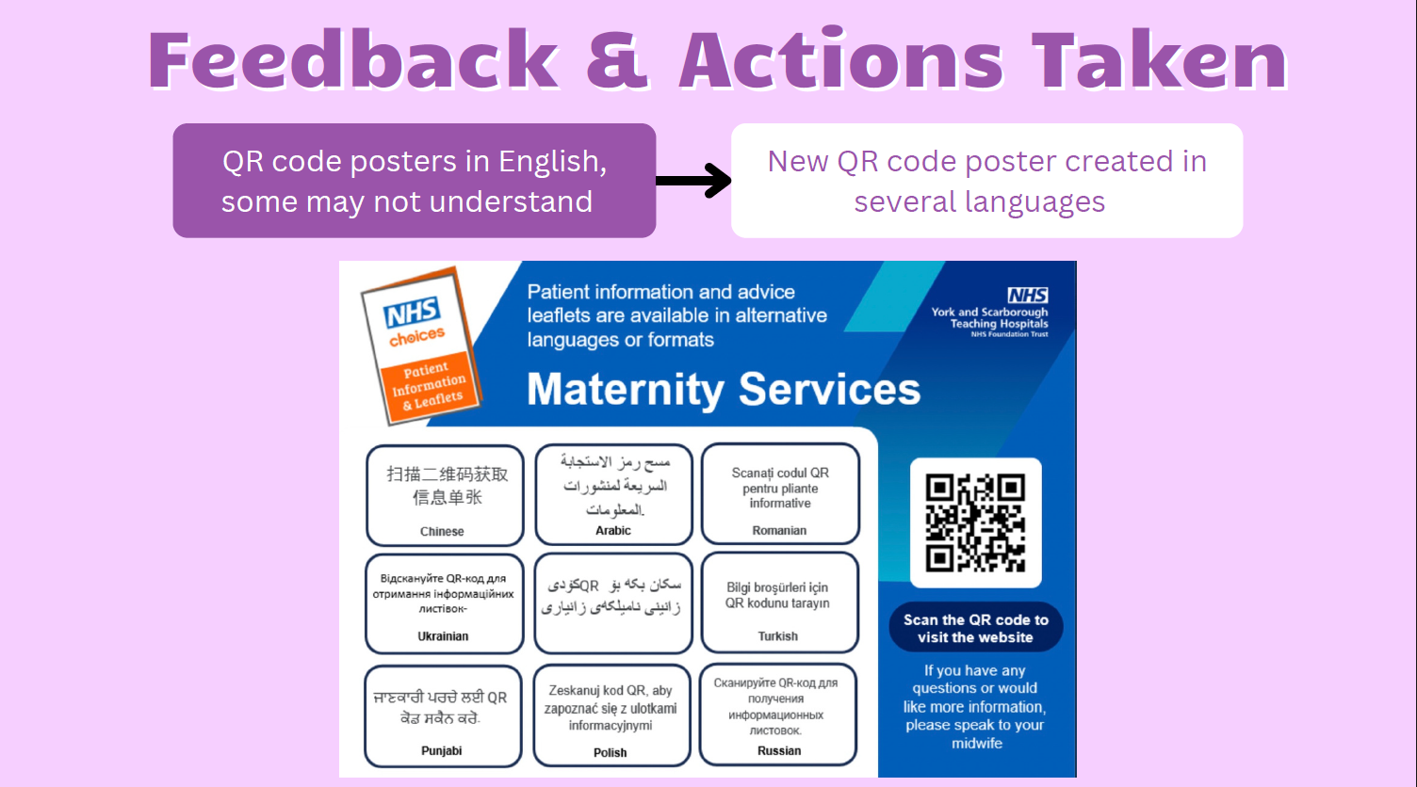

A report from Healthwatch has been received into the experiences of women’s care in the postnatal period for Scarborough and East Riding area. All key actions that have not already been taken and addressed have been added to the MNSIP. 52% of service users would have liked more support in the postnatal period and for the care they received to be in person and at their own home as well as more of them, particularly where they had a complex birth. It also identified that the inequality gap widens for those women unable to afford private support with antenatal education classes and informal feeding support. With regards to perinatal mental health support, 72% of women were asked how they were feeling by midwives but felt that when they required this specific support it was limited and very confusing with all the different services but that there also a lack of social support.

**Workstream 2: Growing and Retaining our Workforce.**

The service continues to await the full report of the culture score survey. This will be shared in the early part of July and the senior leadership team will work with the culture coaches and frontline staff form across maternity and neonatal services to identify the actions to be taken to address the issues reported. This work will also include the outputs of the NHS staff survey.

A new process has been developed to support the approval for job essential training and continued professional development opportunities. Staff are required to be clear about the benefits of the course/training they wish to undertake and how it will develop them as well as the benefits to the improving the services we provide. The decision to support the training or not is undertaken by an MDT panel every 6 weeks to ensure equity of opportunity for all staff across the services. It will also provide a record of additional training and development staff have undertaken to support development of the services.

Senior leaders across the family health care group are undertaking a two-day development course in all aspects of line management facilitated by the HR and finance teams. The first cohort attended in May 2024 and the second will be undertaken in early October. The days have evaluated very well, and the benefits are already being seen.

Recruitment of staff is focused for the Scarborough site to address the current vacancy of just under 9 WTE, with positive recruitment of experienced Band 6 midwives form other parts of the country. The service is working hard to support the 13 student midwives who qualify in September this year to be able to secure a substantive post with us.

The interviews for the Deputy Director of Midwifery are on the 20th of June and there are 2 strong candidates. The assessment for each candidate will be a 3-stage process consisting of a stakeholder panel with a discussion topic led by the candidate, a care round on ward G2 and then a formal interview panel.

**Workstream 3: Developing and sustaining a culture of safety, learning and support.**

NHS Resolution undertook a thematic review of early notification cases received from York and Scarborough service between 1st April 2017 and 21st October 2023. There have been no cases requiring to be reported by the trust from late 2022 to date. The findings of the cases reviewed, and the recommendation made by NHSR are being reviewed and a full response will be provided to them in July.

Implementation of the maternity and neonatal quality and safety governance framework continues, with key pieces of work being tested and embedded. These include the review of the PMA strategy, the clinical guidelines review and formalising an annual forward audit plan as well as development of the Training needs analysis and the MDT PROMPT faculty.

**Workstream 4: Standards and structures that support and underpin safer and more personalised and equitable care.**

There have been significant challenges in driving forward the key actions for this workstream as it is heavily dependent on Business cases being approved and Investment.

Some key areas can now be taken forward following the funding received form NHSR for CNST year 5 specifically the development of Transitional care.

A full Equality Impact assessment has been done for maternity and neonatal services if investment is not achieved and the risks that the service currently carries as a result.

**Annex 1 Summary of Maternity & Neonatal Quality & Safety Metrics Delivery April 2024.**

