Use of the Roche Accu-Chek Performa

for

Glucose Analysis

Document Author | Clemora Thomas & Jane Mason
Document Owner | Clemora Thomas
Approved By | Emma Lovie
Review Interval | 2 years
Location of Copies | Hard copies supplied to all community teams with Performa meters

Changes from last version of this document
Include details for setting date/time

Contents
1 Purpose and Principle 2
2 References 2
3 Equipment 2
4 Personnel Authorised to Perform Procedure 2
5 Sample Requirements (including COSHH Risk Assessment & First Aid) 3
6 Chemicals (including COSHH Risk Assessment & First Aid) 3
7 Reagents 4
8 Risk Assessment 4
9 Calibration 4
10 Quality Control 5
10.1 How to measure quality control 5
11 Method 6
11.1 Analysing Patient Capillary Samples 6
12 Reporting of Results 7
13 Reference Ranges 7
14 Assay Performance & Known Limitations 7
14.1 Precision and Detection Limits 7
14.2 Limitations for use 8
15 Maintenance and Troubleshooting 8
15.1 Cleaning the meter and work station 8
15.2 Changing the battery 9
15.3 Other meter problems 9

Purpose and Principle
The Roche Accu-Chek Performa system is intended for diagnostic use in the quantitative determination of blood glucose levels in venous, capillary, arterial and neonatal whole blood samples. It can be used by any healthcare professional to monitor glucose levels in any clinical setting providing they have completed the required training. The test strip is impregnated with a modified glucose dehydrogenase enzyme which converts glucose into gluconolactone. This reaction creates an electrical current which the meter converts to a blood glucose result. The sample and environmental conditions are also evaluated using a small AC current.

References
- Accu-Chek Performa operator’s manual
- Accu-Chek Performa test strip insert
- Method evaluation stored in Q-Pulse under file name PC-EVA-ROCHE
- MSDS safety sheets can be found on the Roche web site www.cobas-roche.co.uk

Equipment
- Roche Performa meter
- Single use finger prick lancets
- For issues and support contact:
Community POCT | 01904 725294 (ext 772 5294)
York POCT | 772 5890
Scarborough POCT | 771 2659
Please provide the following information:
- Serial number of the meter
- Location of the meter
- Name of the meter owner
- Description of the error

Personnel Authorised to Perform Procedure
Health care professionals who have undertaken and completed the initial face to face training as set out in PC-TEM-TSPERF

Sample Requirements (including COSHH Risk Assessment & First Aid)
- 0.6uL of fresh capillary, venous or arterial blood
- Heparin (sodium/lithium ) anticoagulated venous samples can also be used
- All human blood samples must be treated as potentially BIO-HAZARDOUS.
- Approved Personal Protective Equipment (PPE) including lab coats, gloves and eye-protection must be worn when handling open blood samples or derivatives thereof.

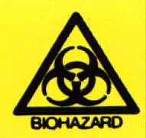 | When performed according to the protocol detailed in this SOP, and in conjunction with adherence to Trust Policies and Good Laboratory Practice, the handling of patient samples represents minimal risk to staff.
Exposure to Bio-Hazardous Material
In the event of a needle stick injury or accidental blood splashes to eyes or mouth:
- If skin has been punctured encourage bleeding by gently squeezing. Wash with soap and running warm water then dry and dress the wound.
- Splashes to the eyes: irrigate eyes thoroughly with eye wash / saline
- Splashes to the mouth: gargle with drinking water (avoid swallowing)
Contact the Occupational Health Department / Emergency Department for guidance and report all adverse incidents to your line manager / complete a DATIX form.
Disposal of Patient Samples
Ensure compliance with the Laboratory Medicine Policy for the Retention, Storage and Disposal of Laboratory Samples: LM-POL-RSDS.

Chemicals (including COSHH Risk Assessment & First Aid)
The manufacturer indicates no particular hazard involved with use of the reagents.
GENERAL FIRST AID
The following first aid guidelines may be applied to all the substances detailed in this SOP.
Eyes: Irrigate thoroughly with water. At least 10 minutes is the recommended duration. Sterile saline is also available at the eye wash stations.
Lungs: Remove from exposure, rest and keep warm.
Skin: Wash substance off skin thoroughly with water. Remove contaminated clothing and wash before re-use.
Mouth: Wash out mouth thoroughly with water and give plenty of water to drink.
Remember – If at all concerned about the nature or severity of the problem, SEEK MEDICAL ADVICE.

Reagents
- Accu-Chek performa test strips (ref: 05225469) supplied by pharmacy
Store between 2-30C. Do not freeze.
Use at temperatures between 14-40C and humidity 10-90%.
Store all unused strips in their original container and close the lid immediately after use.
- Accu-Chek performa control solutions (ref: 05078164) supplied by pharmacy
Store controls between 2-30C. Do not freeze.
Once the controls solutions have been opened they last 90 days and must be dated for first use or expiry.

Risk Assessment
For the full assessment please see PC-HSR-PERF available from POCT Office

COSHH and Risk Assessment

This SOP and the associated risk assessment(s) have considered all hazards and necessary precautions required to control any risks identified. Where appropriate this is detailed in the COSHH assessment and Risk Assessment. Any risk; where possible is mitigated and or monitored with health surveillance to ensure health and safety for all those affected by this procedure

Calibration
The test method is referenced to the hexokinase method and is traceable to the NIST standard. A Calibration must be carried out before you use a new meter and every time you open a new box of test strips and when the error codes below are displayed
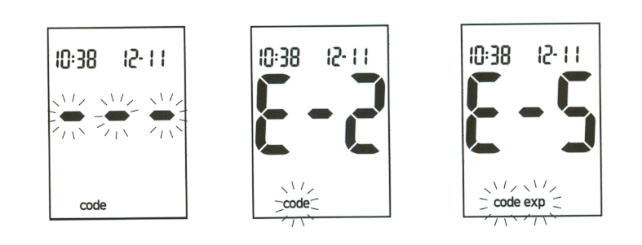
- Make sure the meter is turned off
- Turn the meter over so that you are looking at the back
- Remove the old code key from the right hand side of the meter and discard
- Insert the new code key until snaps into place
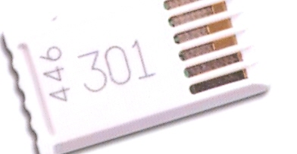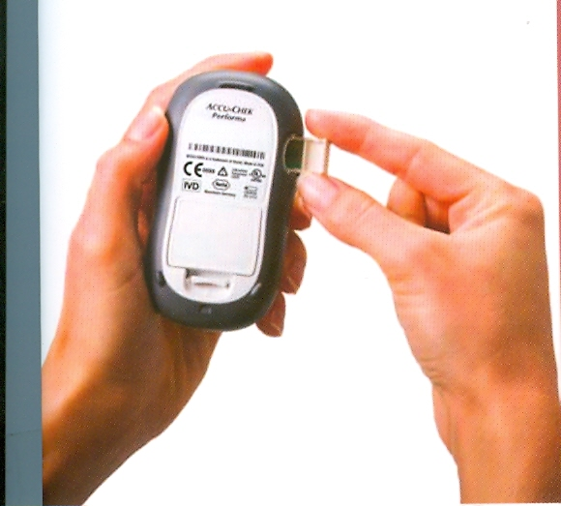
- Turn on the meter. A 3 digit code number will appear. This code must always match the code number on the ‘key code’ and the ‘CODE’ printed on the side of the container of test strips.
- Ensure that the clock in the meter has been set to the correct time and date

Quality Control
Users of the Performa Meter are asked to carry out the following two types of Quality Control
- Internal Quality Control (QC): Two levels of QC solution must be performed once a week and in addition on every day the meter is used to analyse a patient blood sample.
- External Quality Assurance (EQA): All meters are enrolled in an EQA scheme. Every 3 months POCT will distribute EQA samples with instruction letters to each of the Community Hub Admin Teams. The admin teams will, in turn, distribute the EQA to each member of staff assigned the use of a Performa meter, please follow the instructions set out in the accompanying letter and return EQA results promptly.
EQA reports are monitored by the POCT coordinator and discussed at the POCT committee meetings.

How to measure quality control
- Insert a test strip into the meter (the meter should automatically turn on)
- The code number displayed MUST match the code number on the pot of test strips
- Pick up the first control to measure (there is Level 1 and Level 2, they can be run in any order)
- Mix the bottle gently, remove the cap and wipe the tip of the bottle. Squeeze the bottle gently until a drop forms on the tip and touch this to the front edge of the test strip. Replace the cap on the bottle.
- A result will appear on the display along with a control bottle symbol and a flashing ‘L-‘ at the top of the screen. Press the right hand arrow button once for level one ‘L1’ and twice for level two ‘L2’. Press the button on the top right hand side of the meter (power button) to confirm and to commit the result to the meters memory.
- ‘OK’ and the result flash alternately on the display if the result has passed.
- ‘ERR’ will appear if the result has failed. CHECK:
    - The QC material is in date and well mixed.
    - Retry if with new QC material.
    - Retry using a new pot of strips.
    - Contact the point of care team as detailed in section 3 if it fails again and quarantine the meter.
- The QC MUST be recorded in the QC log book for the meter, ensuring the lot numbers are recorded and the entry is signed..

Method

Analysing Patient Capillary Samples
- The test may be requested verbally by qualified members of staff, clinicians or via documented protocols. Please document the source.
- Protective gloves must be worn at all times.
- Take the work station and glucose meter to the patients’ bed side.
- Positively identify your patient (name, DOB and NHS number)
- Explain the procedure to gain verbal consent.
- Ask patient which finger they would like the sample taken from. If they show no preference please use the middle, ring or small finger
- Clean the patients’ hands or finger prior to testing. DO NOT USE ALCOHOL WIPES OR GEL.
- Insert the test strip into the bottom of the Performa meter as far as it will go, with the lettering facing upwards. The code number displayed MUST match the code number on the pot of test strips. A drop symbol will appear on the display to show it is ready for the blood sample. Remember to close the pot of strips.
- With the single use lancet, puncture the chosen finger on the side of the pad no lower than the nail bed. Draw a small drop of blood for use on the test strip. If no blood is visible milk the finger from the heel on the hand downwards.
- Give the patient a clean swab for the puncture site when test is complete.
- The result is available after 5 seconds. Please ensure the result is documented in the patients records and escalated if required.
- All waste materials should be disposed of in accordance with local guidelines

Reporting of Results
Results outside the range (<4.0->16 mmol/L) for patients in secondary care should be escalated immediately to medical staff in charge of the patient. In community results outside the patients agreed target range (recorded on the patients insulin prescription chart) should be escalated to the case manager /GP.
All results are obtained in mmol/L. The meter is capable of analyzing glucose levels between 0.6mmol/L and 33.3mmol/L. Results less than 0.6mmol/L display LO at results screen. Results above 33.3mmol/L display HI at results screen. Results should be documented in the patients’ notes.

Reference Ranges
- Fasting glucose: 2.5- 6.0mmol/L (taken from the WHO guidelines).
- Critical Alert : < 4.0mmol/L, > 16.0mmol/L. Please escalate your patient immediately. (Limits set by diabetes specialist team).
- Hypoglycaemia: < 4.0 mmol/L. Patient should be treated as per the Hypoglycaemia protocol and re tested following treatment (protocol written by diabetes specialist team and available on the Trust Intranet).

Assay Performance & Known Limitations

Precision and Detection Limits
- Inter batch precision
 | Low | Medium | High
Roche Mean | 2.03 | 11.19 | 19.09
SD | 0.14 | 0.36 | 0.49
CV | 6.98 | 3.24 | 2.55
York mean (n=20) | 2.47 |  | 16.48
SD | 0.17 |  | 0.56
CV | 6.80 |  | 3.4

- Intra batch precision
 | Low | High
Roche Mean | 2.75 | 17.30
SD | 0.07 | 0.14
CV | 2.57 | 0.82
York Mean(n=20) | 2.47 | 16.7
SD | 0.08 | 0.33
CV | 3.0 | 2.0

- Assay detection limit.
The lowest value displayed is 0.6mmol/L. The measurement range is 0.6-33.3 mmol/L

Limitations for use
Common interfering substances known to cause over estimation of POC blood glucose are:
- Intravenous administration of N-acetylcysteine. Do not use Accu-Check meters during intravenous infusion of N-acetylcysteine.
- Blood Galactose in excess of 0.83 mmol/L
- Triglycerides in excess of 20.3 mmol/L
- Intervenous administration of ascorbic acid which results in blood concentrations in excess of 0.17 mmol/L

The meter should not be used with capillary samples on patients with compromised peripheral circulation as the results will not reflect the true physiological blood glucose level. This may apply in the following conditions:
- Severe dehydration
- Diabetic ketoacidosis
- Severe hypotension
- Severe shock
In these occasions you may use venous or arterial blood on the meter.

The meter should only be used on patients with a haematocrit between 10% and 65%.
The system is approved for use with neonatal blood but caution is advised in the interpretation of glucose values below 2.8mmol/L.

Maintenance and Troubleshooting

Cleaning the meter and work station
- The meter and workstation can be cleaned with commercially pre-moistened cleaning cloths such as Clinell Wipes.
- Cloths dampened with mild soapy water, 70%isopropyl alcohol or 0.625% sodium hypochlorite are acceptable.
- Wipe away any excess cleaning solution before use.
- DO NOT ALLOW LIQUID TO ENTER THE STRIP PORT
- Do not spray the meter or base unit directly.
- Do not use solutions containing ether polyhexanide or mixtures of bleach and detergents.

Changing the battery
- Open the battery door on the back of the meter
- Remove the old battery
- Insert the new lithium battery type 2032 with the + side up
- Replace the battery back
- Turn on the meter and confirm the time and date are correct. Use the on off button to confirm and forward and back arrows to edit.

Other meter problems
- Please check the display is operational:
  - Ensure meter is OFF
  - Press and hold ON/OFF button (top right hand side of meter)
  - The display should appear like the following image:
- Contact POCT as per the guidance in section 3

Setting Date/Time
- With meter ON, press and hold the power button for 4 seconds until the Year flashes on the display
- Use the arrow keys to amend the year
- Press and release the power button to set the Year. The the month will now flash
- Use the arrows to set the month, then day, the hour, then minutes.

