Additions to Lab Orders
The method detailed below allows you to add items to a recent sample via Order Comms, specifically the ORDER screen:

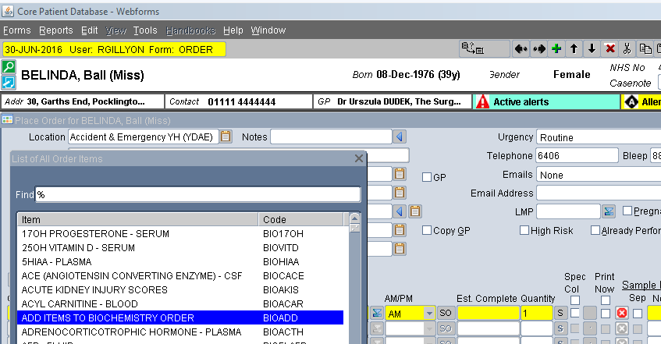

This new item, BIOADD, allows you to add extra items to an existing sample. Select it just like you would a normal test, and process. There is no need to print or mark as "sample taken." On ordering, 3 questions are raised, all of which must be answered:

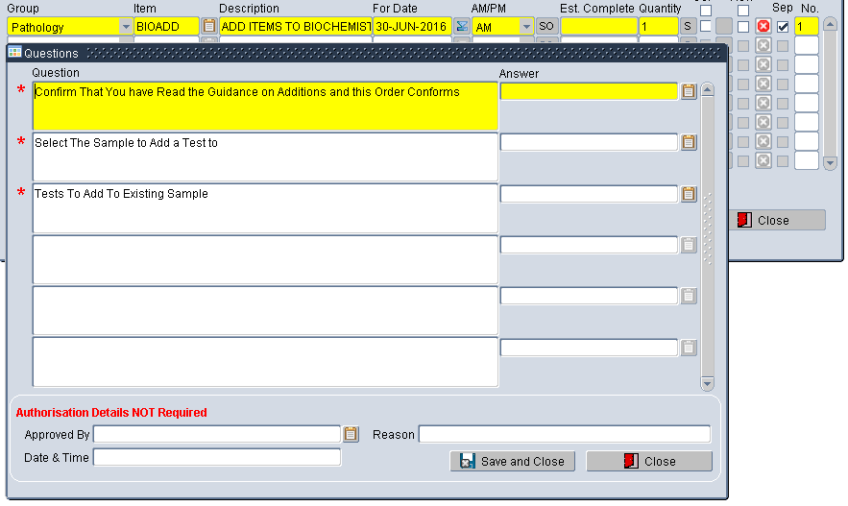

The first asks you to confirm you have read the guidance provided by Laboratory Medicine about Additions. Unless you answer this "Y" you cannot continue.
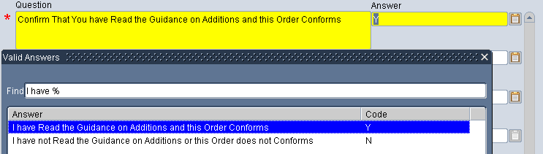

The second question asks you to pick a recent bag sent to Pathology. This will show all biochemistry and haematology samples taken for this patient in the last three days. Select the sample you want using for the added tests.
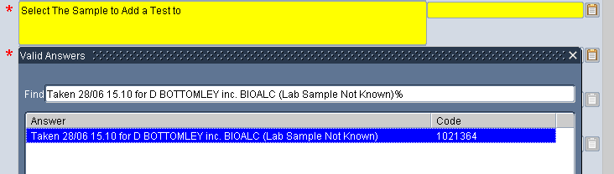

The third question asks you to add specific tests to the request. Multiple tests can be specified (up to 5).
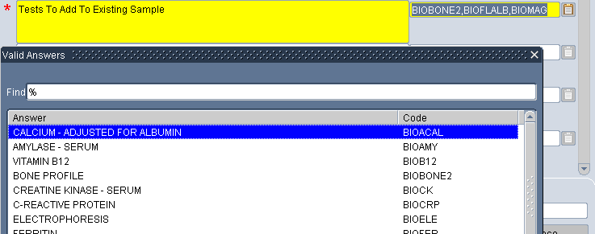

While Troponin is on the list, you will only be allowed to add this if the sample was taken less than 24 hours ago.

Once you place the order, the lab are notified of the request.

