Focus on…….
Energy Management

Why do we need to look at how we use our energy?
A range of conditions can cause pain, breathlessness and fatigue that affects our ability to do the tasks we want and need to be able to do. Fatigue, pain or shortness of breath can all lead to reduced activity but this can then worsen our overall health and wellbeing.
Every task and activity we do needs energy. If we don’t have enough energy then we may be unable to meet the demands in our life.
Fatigue is the feeling of overwhelming tiredness that doesn’t get better with rest. It may affect as many as 1 in 5 people at a time and can be caused by many factors including health conditions such as heart and lung diseases, neurological conditions, Cancer, Diabetes, chronic pain, Arthritis, Depression and Anaemia. Half of people with COPD (Chronic Obstructive Pulmonary disease) struggle with severe fatigue ¹ and as many as 90% of people with Cancer have cancer-related fatigue ². Sometimes the treatments to manage these health conditions, such as cancer treatments, can also cause fatigue. Shortness of breath and pain can lead to avoiding activity which affects our muscle strength, self-confidence and independence.
Shortness of breath, pain and fatigue might cause difficulty managing simple tasks, concentrating and remembering things, difficulty sleeping, feeling lightheaded or breathlessness (separate to the medical condition).
It important that your healthcare professional, such as Doctor or Specialist nurse, is aware if you are experiencing symptoms of fatigue, breathlessness or pain to ensure you are receiving the correct treatment.
Fatigue, pain and shortness of breath can affect what we do, how we feel and cope with life and how well we sleep. All these things can then worsen the fatigue. This is seen in this cycle:

The Vicious Cycle of Fatigue 3(adapted to include ‘breathlessness or pain’)
Fatigue, breathlessness or pain
Behaviours:
- Avoid certain activities
- Stop completely certain activities
- Cancel social occasions
- Seek rest (naps, increased time in bed, sitting for long periods)

Consequences:
- Loss of source of pleasure/ gratification
- Social isolation
- Loss of alternative ways to rest
- Frustration, low mood
- Physical deconditioning
- Dissatisfaction in relationships
- Decrease of motivation
- Sleep disturbance

Inactivity

We can find ways to break this cycle and lessen the effects of the fatigue, breathlessness or pain.
Why is it important?
Fatigue affects the things we do, how we are able to cope with the demands on us, our roles and our relationships. If we feel unable to manage all these things it can further affect how we feel about ourselves. ⁵
- I don’t feel I get anything done
- My life’s a struggle
- Just little things are such hard work
- I can’t be bothered
Energy management in not necessarily about increasing or decreasing activity levels, but it is about…. ⁵
- Using the energy you have wisely to make the most of it
- finding the balance between activity and rest
- making the most of your energy
- getting the most activity out of the energy you have

A healthy approach to life
An Occupational therapist can help you live the life you want to lead. Being able to do the activities that are important to us helps our health and our mental wellbeing. It is well known that being involved in activities actually helps to reduce the fatigue and helps us achieve more. Being involved in the activities that are important to us has a positive impact on our mental health which also reduces fatigue. It is important for us to feel a sense of achievement in order to break the cycle of inactivity that increases fatigue.
Getting into this positive cycle can take some planning and your Occupational therapist can help find ways for you to achieve this which will lessen the impact of the fatigue⁷.
Managing limited energy levels
Energy is created by many systems in the body; the respiratory and circulatory systems transport oxygen, the digestive system releases energy from food and the hormones that regulate the use of the energy ⁶. Any disruption to our bodies affects the ability to make or use energy. It is useful to consider our energy as a battery or credit card and that we need to plan how to efficiently use the energy or resources that we have.
To manage our energy levels we need to understand them and how they may change through a day or after we have done certain activities. Some activities will make the fatigue worse while other activities may lessen the fatigue.
Action!
Speak to your healthcare professional about your fatigue, breathlessness or pain to ensure you are receiving the correct treatment.
Try keeping a diary of your activities and levels of fatigue over a few days. Make a note of when and how well you sleep and what and when you eat. After a few days you may see some links between certain activities, sleep etc. and your fatigue. You can then use this to best manage the energy you have to do the activities that are important to you.
Here are some examples of fatigue diaries you may want to try.
Macmillan fatigue diary https://be.macmillan.org.uk/be/p-24953-your-fatigue-diary.aspx
Activity diary example 1 From The Christie ⁴
Activity diary example 2

Hints, tips and useful information
There is lots of information available to support managing fatigue or reduced activity due to breathlessness or pain. The following information sheets cover different aspects of energy conservation as well as some worksheets for you to use. They are intended to support your understanding of your own symptoms and how they affect you. If you have any concerns or questions, please speak to your healthcare provider. Your healthcare provider may feel it would be best for you to receive some help and advice from an Occupational Therapist if you have not already.
- Prioritising
- Pacing
- Planning
- Goal setting
- Rest
- Relaxation
- Sleep
- Communication
- Adapting activities and the environment

Positive impact of energy conservation…. ⁵
- I’m kind to myself
- I have more energy for the important things
- I can relax better
- I know I can ask for help
- I recognise my limits
- I feel more in control

References:
¹ ‘Fatigue is highly prevalent in patients with COPD and correlates poorly with the degree of airflow limitation’ (2019) Goertz et al. Therapeutic advances in Respiratory disease (13)
² ‘Coping with Fatigue (tiredness)’. Macmillan. https://www.macmillan.org.uk
³ The Vicious cycle of fatigue from ‘Fatigue after concussion: Epidemiology, causal factors, assessment and management’ (2019). Cambridge University Press
⁴ Activity Diary, https://www.christie.nhs.uk/media/7319/7-helen-bowker.pdf
⁵ ‘Using your energy wisely. Tips to help you conserve your energy’ (2017) Guy’s and St Thomas’s NHSFT.
⁶CFS/ME self management workbook (2012) by Torbay and South Devon Health and Care
⁷ Management of Cancer Related Fatigue (2008) A Barsevick, T Newhall & S Brown. Clinical Journal of Oncology Nursing
⁸ Royal College of Occupational Therapy - https://www.rcot.co.uk

Daily Activity Diary – The Christie, NHS Foundation Trust
There is an example on the next page
Time | Description of Activity | Food and drink consumed | Fatigue  1=no fatigue  10=extremely fatigued | Mood – happy, sad, calm | Comments

Example diary sheet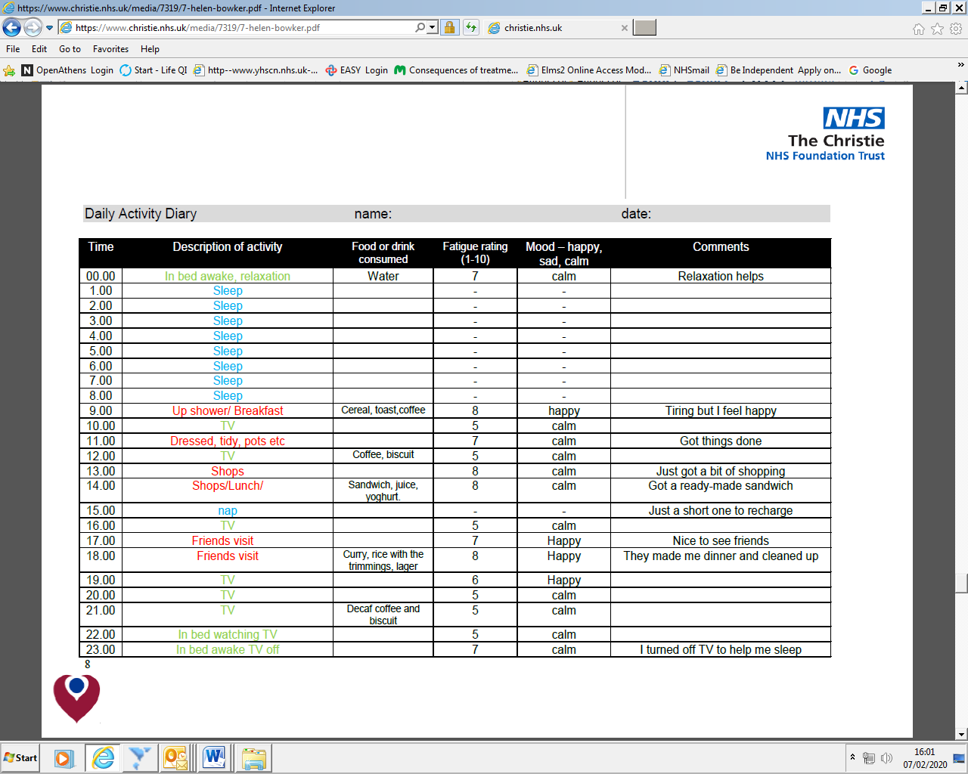
Activity Diary
This diary will allow you to record your activity and score your fatigue, breathlessness and anxiety throughout the day. This will identify any relationships between activities carried out and your levels of fatigue, breathlessness and/or anxiety.
Daily routine- activities carried out | Fatigue, breathlessness and anxiety score 0-10
Record daily activities e.g having a shower, preparing a meal and visiting family.  Record meal times, sleep and rest periods  06:00  07:00  08:00  09:00  10:00  11:00  12:00  13:00  14:00  15:00  16:00  17:00  18:00  19:00  20:00  21:00  22:00  23:00  24:00 | Please put the corresponding shape around the score that best fits how you feel.  0= no problems 10= severe problems  Fatigue =  Breathlessness =  Anxiety =  First thing in the morning  0 1 2 3 4 5 6 7 8 9 10  Mid morning  0 1 2 3 4 5 6 7 8 9 10  Lunch time  0 1 2 3 4 5 6 7 8 9 10  Afternoon  0 1 2 3 4 5 6 7 8 9 10  Early evening  0 1 2 3 4 5 6 7 8 9 10  Late evening  0 1 2 3 4 5 6 7 8 9 10  Before bed  0 1 2 3 4 5 6 7 8 9 10

