Next of Kin
Hospital Providers 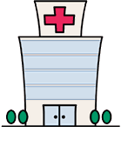
Community Providers

Karen Pearce - 07917184539
Jo Blades - 07795 126473
Learning Disabilities Liaison Nurses

Learning Disabilities Hospital Passport
The following information should be given to oncoming ward staff during all handovers until the patient is discharged.
On admission please check with the patient or their family/carers that the information in this summary is current and accurate.

Date:
Name | DOB |  | NHS No
Allergies
Home Circumstances
Likes |  | Dislikes

Communication | Personal Care 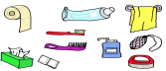 | Other Essential Information
 | Nutrition

