Focus on…….
Pacing
Why do we need to look at Pacing?
Pacing is the strategy we use to manage our activity with the amount of resources, such as energy, we have available, to avoid being over or under active; known as ‘boom and bust’. It is about breaking up tasks into smaller activities or parts, so that we can do bits at a time rather than all at once, changing how we complete the task, possibly changing our standards and how we create ‘rest’. Pacing can initially create feelings of frustration and resentment, but is crucial in avoiding ‘boom’ and ‘bust’ ¹:
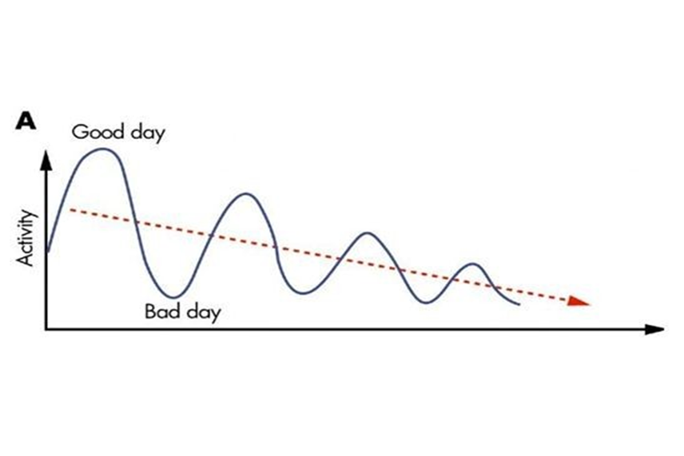Time
Monday - Good day, sun is shining- going to get washing cleared and clean the kitchen
Tuesday – struggling, exhausted, some of the day in bed, really fed up
Wed – still feeling worn out but need to get on as I really need to get some food, don’t want to chat with friends as not great company – shop and unpack as quick as I can
Thurs – Day is written off. Rest all day
Fri – feel better so try and get back on track
Sometimes pushing on to complete a task doesn’t get things done quicker. Sometimes an activity is so important that it is worth the energy use and after effects, such as a party or going to the football match. The importance of the tasks (‘Prioritising’ covers this) will guide how we pace ourselves and the affects our mental wellbeing.

Why is it important?
By using pacing, we plan our time across an hour, a day, a week or even longer. It involves thinking about a task and whether it can break up into parts. What can I manage? Over how long can I spread the task? If you were to ‘clean the house’ you can think of it in small bits such as different rooms, eg ‘bathroom’ or ’bedroom’, or different tasks eg ‘dusting’ or ‘hoovering’. By thinking about tasks in this way you can set yourself aims or goals to stick to. This means that you stop, or change activity to a different type, before you have to stop due to your fatigue, pain or breathlessness. Pacing gives a better sense of control, so positively impacting on how we manage symptoms, as well as being better for our mental wellbeing.
The next section covers how to increase your activity levels- talk to you healthcare professional about whether this is the right approach for you. If this isn’t, you can skip ahead to the hits and tips section.
Activity can be seen as blocks so you can add more of these ‘blocks’ in small amounts. These blocks may be certain amounts of time:
1 minute
1 minute
1 minute
10 minutes
10 minutes
10 minutes

Session 1 Session 2 Session 3
The important starting point is identifying what you can comfortably manage, known as a baseline. From there you can consider how you go about building up your activity levels if that is your aim.
Example of building activity levels:
Standing to wash up. Start with an amount of time you feel is achievable (your baseline). Think about how much you can manage on a good day and how much on a bad day and identify a baseline somewhere in between.
 | ‘Good’ Day | ‘Bad’ Day | Baseline
Standing to wash up | 10 minutes | 3 minutes | 6 minutes
Think about how you can build on this, adding extra time before you rest/ change activity/ change position. Increasing 10% at a time allows you to carefully increase length of time doing an activity.

Keep at the same activity level until you feel ready to increase it in these small amounts. If you are feeling good, don’t be tempted to do longer than planned- stick with it to avoid the potential of the boom and bust. You can use this pacing and planning to help to set personal goals.
Hints, tips and useful information
- Spread your tasks evenly throughout the day.
- Allow yourself regular, planned rest breaks and stop before you become overtired.
- Prioritise what you plan to do
- Can you do some today and some another time?
- Mix active tasks such as domestic tasks with quiet tasks such as reading or emails.
- Work out what rest is to you – some people will find activities more restful than others
- Avoid rushing through tasks
- Will doing it in ‘bits’ affect your enjoyment – there may be times we will want to blow the energy budget because it was worth it- it’s then about planning and ensuring we don’t enter a boom and bust cycle
Get practical…
- Think of an activity you would normally see as one job and break it into smaller tasks using the worksheet
- How did I do? Use the ideal vs actual day worksheet to look at what happened through the day
- Look at the ‘focus on …Planning’ information to put pacing into a daily or weekly plan
- Think about tasks important to you – which of these could be broken up into small parts and not affect your enjoyment or sense of achievement?
- If you are building up activity levels: Pacing Plan - Try setting your own. The example is a walk- be mindful of any unforeseen impacts e.g. seeing a neighbour who may want to chat – think about how you will manage this if it arises so that you aren’t doing more than you planned.

Activities into smaller tasks
- Think of an activity (eg shopping, cleaning the house, having a shower, cooking a meal)
- Think about your activity –what are the different steps to completing the task?
- Think about these steps – do they have to happen at a particular time? Do you need to do them all in one go? Do you need to do all the steps?
- Write a plan of how you would do this task in a number of steps and try it out
- Once you have tried doing the task in smaller bits, write down how it felt… Was it…Easier? Frustrating? I had more energy? I didn’t feel I did it properly? I would do it again? I would do things differently next time?

References
¹ princessinthetower.org/pain-management/pacing-for-pain-management/ [accessed August 2020]

Actual vs Ideal Day

Jot down what happened over a day and then what you would have liked the same day to be like. Think about what the differences are and then look at this again after reading the ‘planning’ sheets.

Time | Actual Day | Ideal Day
7 am
8 am
9 am
10 am
11 am
12 pm
1 pm
2 pm
3 pm
4 pm
5 pm
6 pm
7 pm
8 pm
9 pm
10 pm

Pacing Plan
Week 1 example
Day | Activity | Baseline | Goal
Mon | Walk dog | 10minutes | Walk 10 minutes
Tues
Wed | Walk dog |  | Walk 11 minutes
Thurs
Fri
Sat | Walk dog |  | Walk 12 minutes
Sun
Week 2 example
Day | Activity | Baseline | Goal
Mon | Walk dog | 12minutes | Walk 12 minutes
Tues
Wed | Walk dog |  | Walk 13 minutes
Thurs
Fri
Sat | Walk dog |  | Walk 15 minutes
Sun

My Pacing Plan
Week 1
Day | Activity | Baseline | Goal
Mon
Tues
Wed
Thurs
Fri
Sat
Sun
Week 2
Day | Activity | Baseline | Goal
Mon
Tues
Wed
Thurs
Fri
Sat
Sun

