Specimens that require testing at HMDS, Leeds

LN specimens

LN core biopsies - each site specific sample should be sent to the Histology laboratory in formalin in its entirety (not split between formalin and saline as per photo below) (as per HMDS handbook)
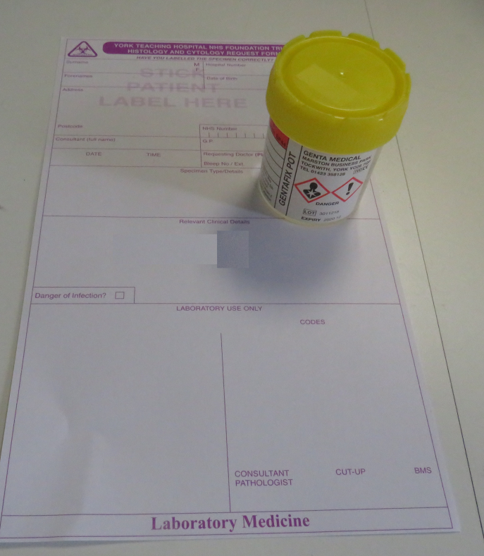

LN excisions should be received fresh or on a saline soaked gauze (not fully immersed in saline).

Marker studies specimens

Skin punch biopsies can be sent to HMDS in formalin (as per HMDS handbook) (please see photo above)

If larger skin excisions are taken for marker studies, please send to the Histology laboratory fresh or on a saline soaked gauze (not fully immersed in saline).
*Please note – if a specimen is going to be retrieved out of routine laboratory hours (Monday to Friday 8.30am-5pm excluding bank holidays) please liaise with York Histopathology and HMDS as both laboratories work these periods with reduced staff.
Further information can be found at: http://hmds.info/hmds-lab-user-guide

