YorCat user guide

YorCat is an interactive catalogue of items held by NHS Library and Knowledge Services across Yorkshire, the Humber and Northern Lincolnshire.
Membership is open to staff and students at the following Trusts; Airedale FT, Barnsley FT, Bradford District Care FT, Bradford Teaching FT, Calderdale and Huddersfield FT, Doncaster & Bassetlaw Teaching FT, Harrogate & District FT, Mid Yorkshire Teaching, Northern Lincolnshire & Goole FT, Rotherham FT, Sheffield Children’s FT, South West Yorkshire Partnership, York & Scarborough Teaching FT.
If you are already a member of the library service at one of the above Trusts then you are part of YorCat. Staff from the Yorkshire Integrated Care System organisations may also join.
If you move to another Trust or member health organisation in the YorCat region you take your library membership with you.
Members can borrow books and multimedia items from any of the YorCat locations, sent to their home library for collection (subject to local restrictions on some items).
Throughout 2024 YorCat will be welcoming Sheffield Teaching FT, Sheffield Health and Social Care FT, Hull University NHS, NHS libraries in Leeds and the Leeds Public Health Resource Centre to further improve the library offer to NHS and public health staff in our region.
YorCat is funded, provided and administered by NHS England and hosted by PTFS Europe.

How to…

Login Register Search Advanced Search Reserve items

YorCat is at
https://yorcat.koha-ptfs.co.uk/

How to Login
If you are already a library member click to login;

Enter your login name (library username or card number) and your password. If it is your first time using YorCat you will have to set your password. Click on the Forgot your password? link and using your login and email address request a password reset.
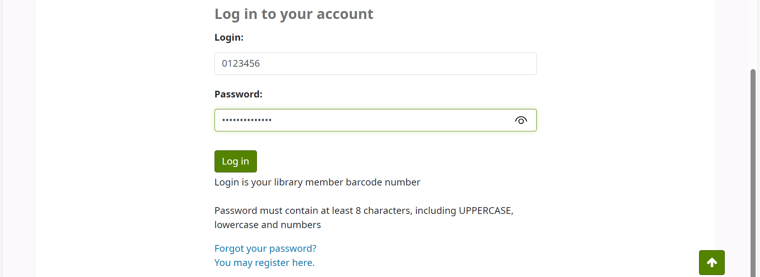
If you do not know your library username then contact your local library – there is a list of libraries at the link on the front page

Please note that if you have library membership already in YorCat but have changed employers then your existing account will have to be transferred rather than a new one created. Contact the library at your new employer to arrange this.
At your first log in you will be asked to agree to the YorCat privacy policy.

How to Register
If you are not already a member of a YorCat library then click on Register.
Select your Home Library from the pull-down list.
Enter details of name and work address. A phone number is required – this can be a work number or mobile. If you wish to receive text messages about overdues and reservations enter your mobile number in the box;
If you want email contact only then leave the above box empty.
“Add email” – all users are required to enter a valid email address, preferably NHS email but personal emails can be used. If your email address is already on the system then you will not be able to save the form – contact your library for assistance.
“Home address” – this is only required by some member organisations, please check the list above the box. If home address is required by your library and you do not fill in this field, you will be contacted to provide it and your account will not be validated until it is recorded on your account.
“Password” – either enter one of your choosing or leave the box blank to generate an automatic password. The password must contain at least 8 characters, including UPPERCASE, lowercase and numbers.
“Additional information” – contract type is required. If you are on a temporary contract then enter the expiry date. Library accounts for permanent staff expire after three years. You will receive a notification prior to this and be invited to renew the account.
Under “Employment details” select the organisation you work for. If it is directly for the NHS Trust then select as appropriate. If you work in primary care or a partner organisation then select as appropriate or select other and put details in the box below.
If a student enter name of University or College and the course.
From the “staff category” list choose your ESR designation or other/non-ESR.
For notifications leave as email only or select email and text. If you want text notifications make sure to put your mobile number in the required box (see above).
Tick to confirm that you have read the privacy policy and terms and conditions and enter the verification code shown.
Once registered you can login and browse the catalogue and reserve any books for collection at your library (see search and reserve below). You will not be able to borrow any items until your library has validated the account. This will be done on the next working day. If you are onsite you can enquire at the library to validate the account sooner. If there are any queries or omissions in the details provided the library will be in touch. If the new account is not validated within 28 days it will be deleted.
Leaving or changing employer
If you are leaving your employer and not moving to another organisation in the YorCat region then please return all library items and let the library know so that they can close your account. Accounts will not be closed if items are still on loan.
If you are moving to another YorCat organisation then contact the you new home library once you start and ask them to transfer your account to them. If you still have items on loan from the previous library they can be returned at the new one. If you have long overdue items or damaged items not paid for on your account you will not be able to borrow items from the new library until the matter has been settled.
---------------------------------------------------------------------------------------------------------

How to Search for items on Yorcat
To do a broad search on a topic enter keywords into the search box

You can search all libraries or just select your own. If you work for an organisation that has more than one library site there will be a search group at the bottom of the selection.
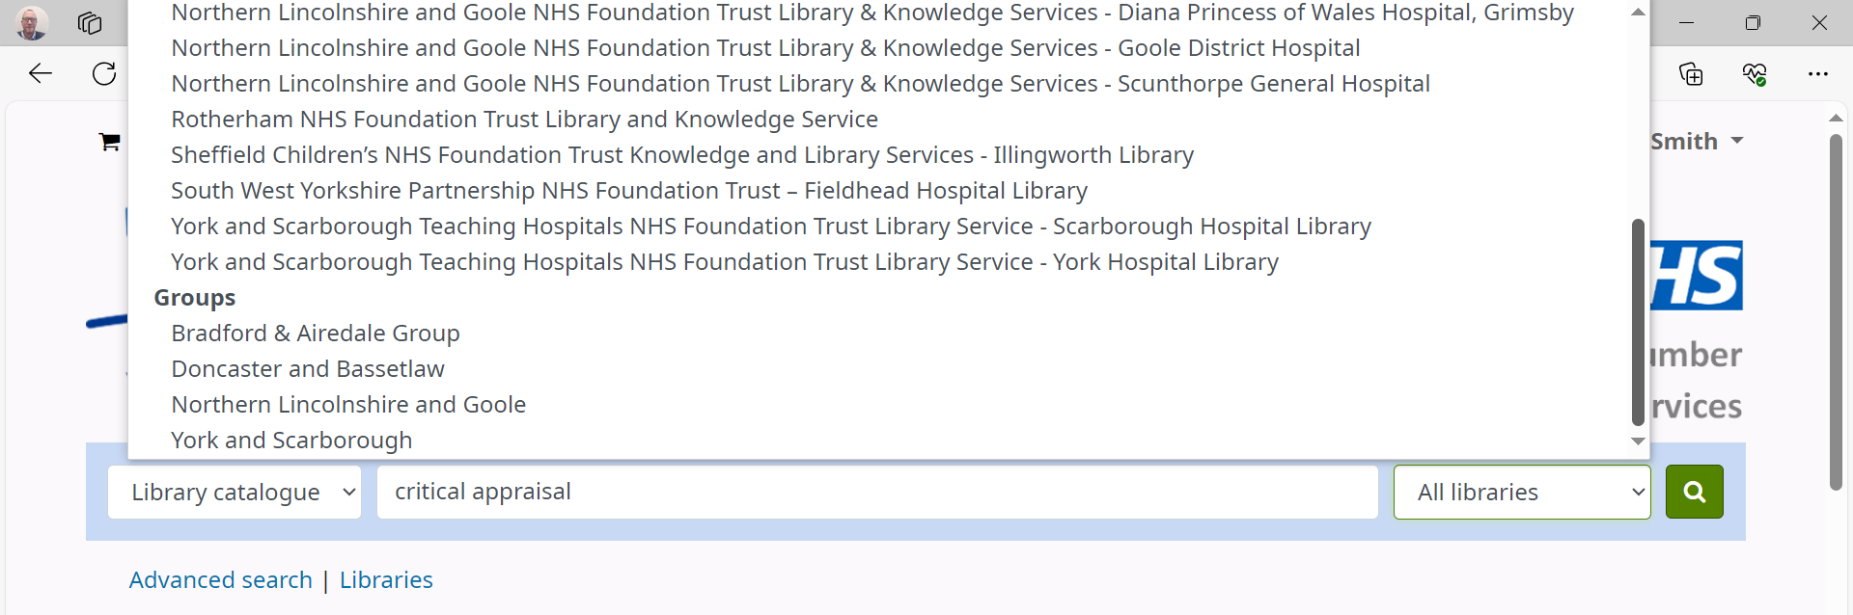
e.g. selecting Doncaster and Bassetlaw will search all three libraries in that Trust.
There are also search groups for regions where different library services are within reasonable distance e.g. Bradford and Airedale.
Your search will bring up a list of items listed by relevance. It will show 20 items per page.
To change the order of books by preference select the pull down at the top right and choose how you would like to see the items listed.
The item record will show where copies are available.
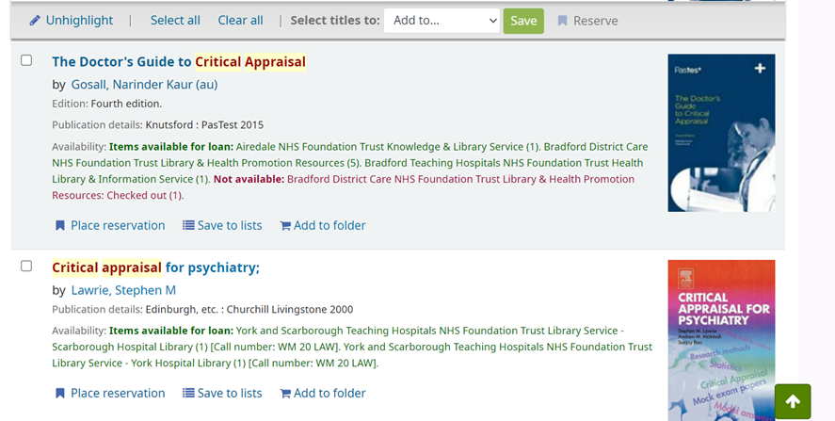
You can refine your search using the criteria in the left hand column e.g. limit to ebook and select one or more libraries. Remember to unselect these restrictions if you want to search widely again by clicking on the x
To select items for consideration click on Add to folder. Please note that when you logout the folder will be emptied. You can email or download the list of items in your folder to look at later.
Each search generates a unique url so you can save this if you want to run the search again another time or you need to log the search as part of an academic assignment e.g.
https://yorcat.koha-ptfs.co.uk/cgi-bin/koha/opac-search.pl?idx=&q=critical+appraisal&limit=&weight_search=1
To reserve any items follow the procedure here

Advanced searching
Click on Advanced search
Enter up to three keywords
Leaving the default as keyword will search broadly across all fields in the item records.

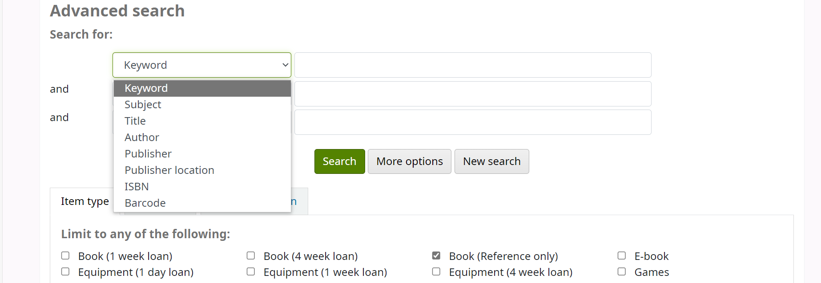
To limit the search change one or more search types at the pulldown.
You can also specify one or more item types to search for by ticking the box next to the item name.
You can limit to a specific collection or shelving location if you want to browse books on a similar theme, e.g. diversity or research methodology. Leave the search boxes blank and tick the collection.
Select a library, or group of libraries if appropriate. You can also select to sort in order by preference and add in a date range for publication.
For very granular searching select More options (right of the green Search button)
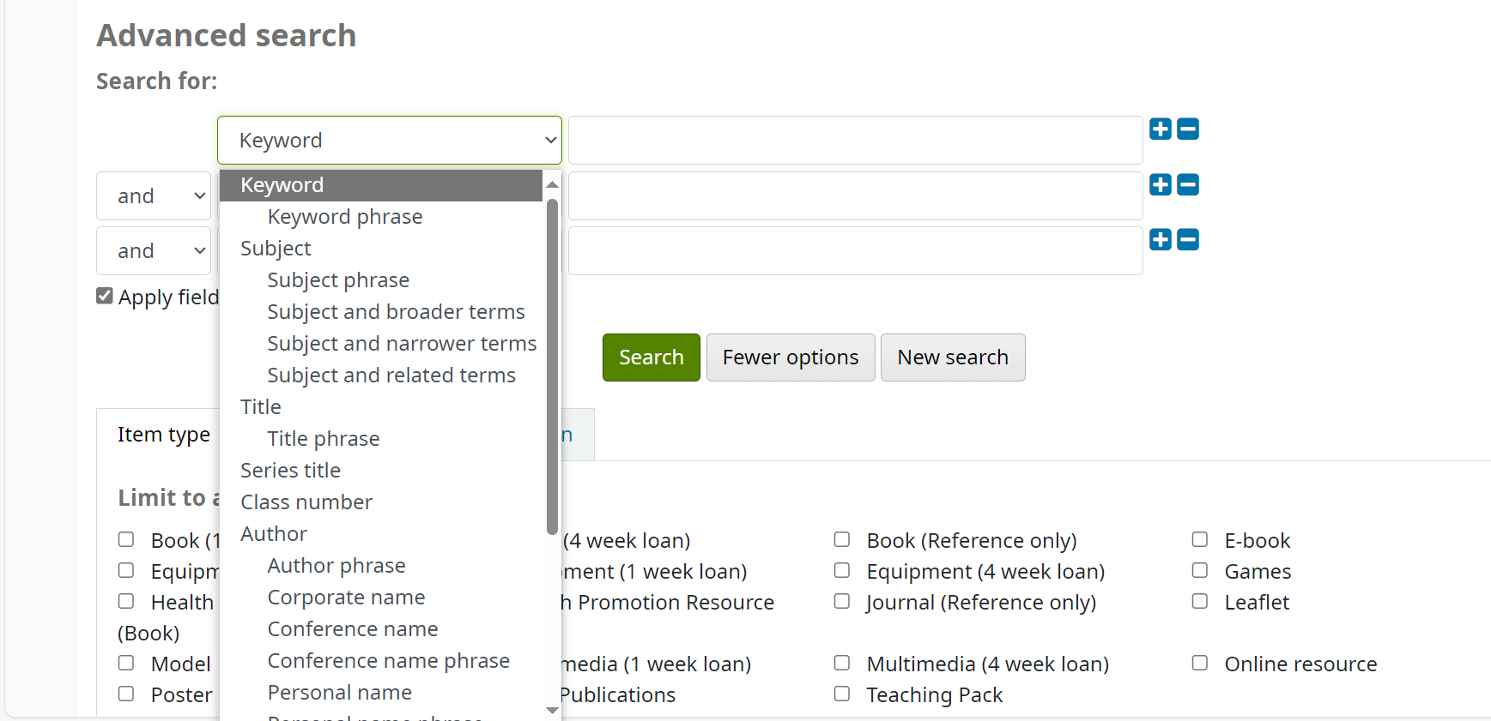
You will have more choice of search fields and be able to use And, Or and Not operators for more specific word limits. Click on fewer options to return.
Your library team will be happy to arrange a one-to-one session to help you get the most out of the search operability on YorCat (and other resources).
Once you have your search results you can save the items in the folder as above.

Placing a reservation
Books and multimedia items can be reserved on YorCat and sent to other libraries. Other media such as models, equipment and health promotion resources can be searched for on YorCat but can only be borrowed from the library they belong to by people who are a member at that library. Please contact the library directly to reserve any of these items, sending the url from the catalogue.
When you find an item you wish to borrow click on Place reservation.
Your pick-up location will default to your home library but you can select another library if convenient.
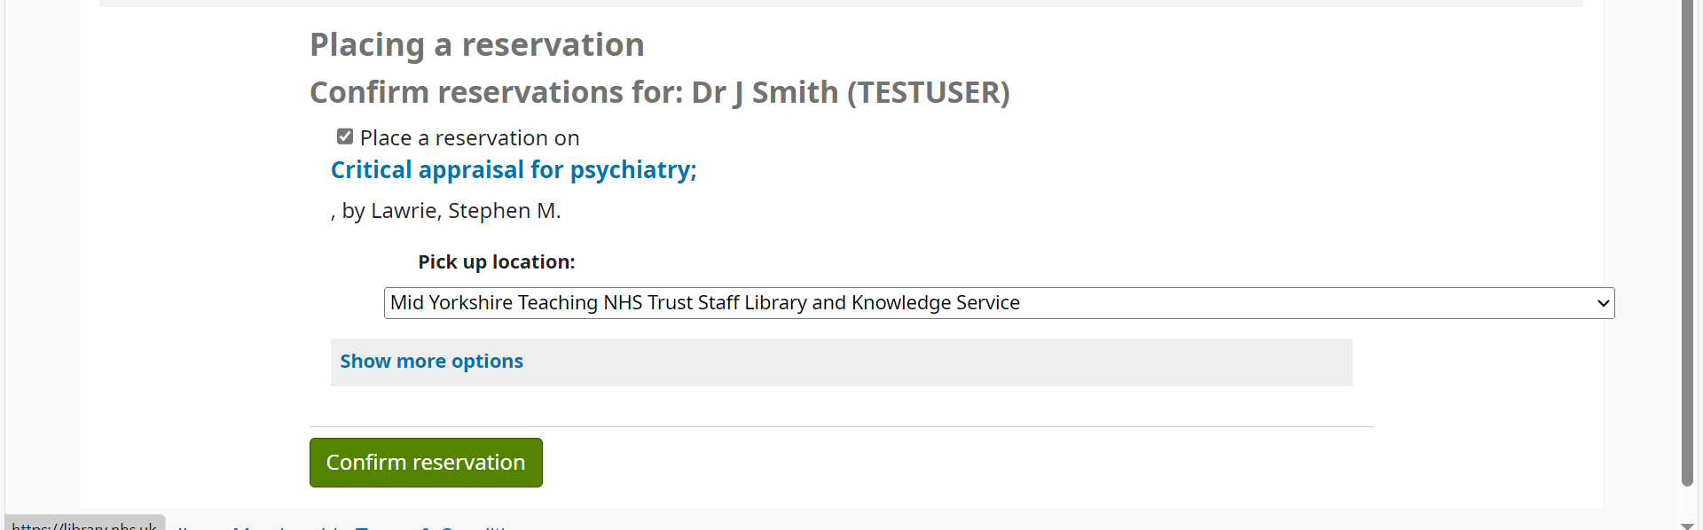
Click Confirm reservation.
You can see the progress of your reservations or cancel them at your summary page
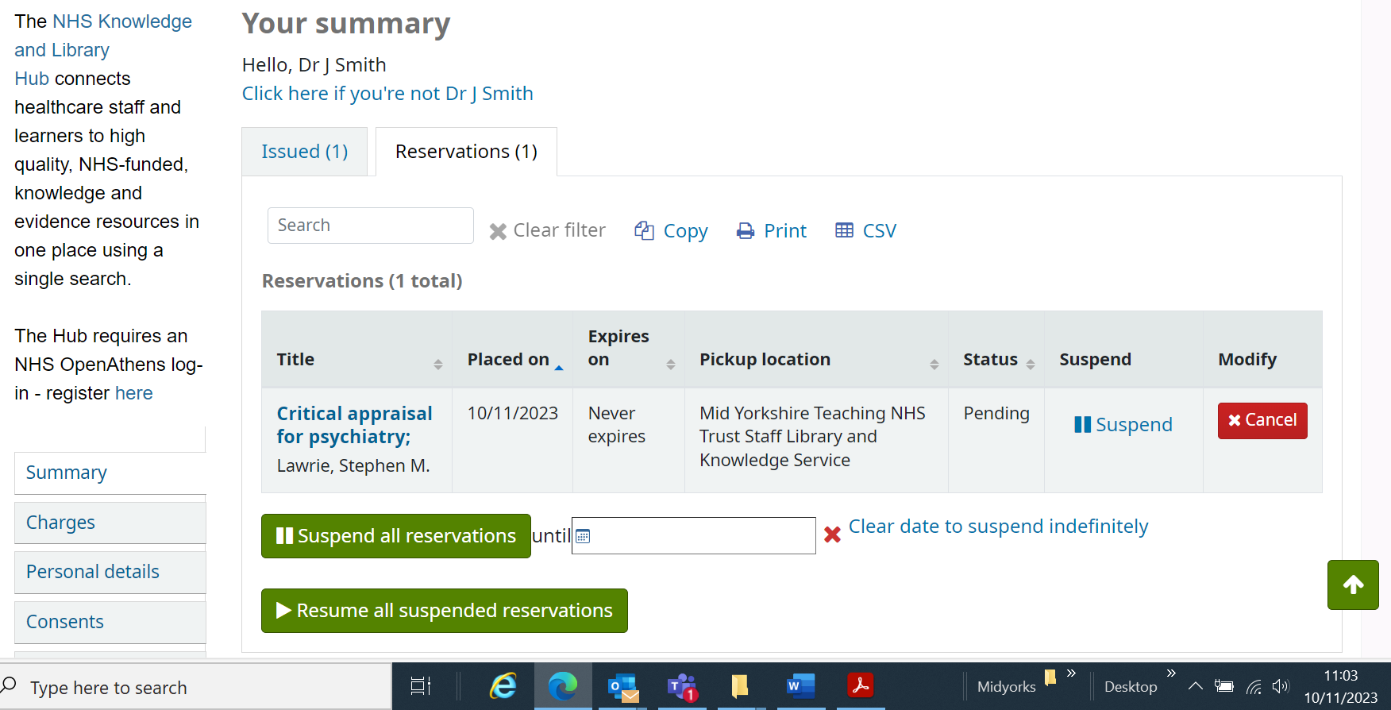

When the book is available at your library you will receive an email (and text if option selected) letting you know to collect it. You will have seven days to collect the item before it is returned to its home library. If the book is from another YorCat library you can borrow it for 28 days (from the date you collect it), and renew the loan five times subject to it being reserved by another user or recalled by the holding library.
You can reserve an item that is currently on the shelves at your home library. Reserve it as above. Library staff will locate and put aside the item first thing on the next working day. If you want the item put aside before then, email the library with details. Each item has a unique url so just copy and paste the link into the email with your request
e.g. https://yorcat.koha-ptfs.co.uk/cgi-bin/koha/opac-detail.pl?biblionumber=59675&query_desc=critical%20appraisal
If you cannot find a particular book you can use the link at the bottom of the search results page on YorCat to make a purchase suggestion or email your library to request a loan from a library outside the region. Journal articles not available through NHS OpenAthens and the Knowledge and Library Hub can also be requested – please contact your library for more information about these services.

